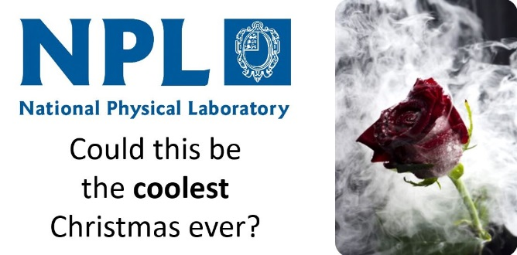
The Hanson Family Science Show Players present
The Liquid Nitrogen Show
Friday 15 December 2017
National Physical Laboratory, Teddington, TW11 0LW
Performances at 4:30pm and 6:30pm each lasting 55 minutes
Refreshments available from half hour before show starts
Backed by popular demand, from the Watermans Art Centre, Brighton Science Festival, etc.
this critically acclaimed show returns to raise money for charity.
Pitched for an ‘all ages’, there will be bangs, molecular dancing and on-stage participation.
Afternoon (4:30pm show) tickets: http://tinyurl.com/2017NPL4
Evening (6:30pm show) tickets: http://tinyurl.com/2017NPL6
£5 per seat, all proceeds to Teddington Memorial Hospital.

