Giraffes Guidance for Learning at Home
From Week 3 onwards, I will be uploading a short Phonics and Maths video each day. You can choose when you would like to fit them into your timetable but, as before, I have provided an example of a daily routine. As there is a maximum video time on tapestry, the lessons will be general an d then I will provide links and suggestions to the next step in learning to be done independently. This is where activities can be differentiated to your child’s ability.
I will continue to email/call once a week to check in with each family. Please continue to check your emails so that we can keep in touch.
As the period of time away from school extends, tapestry will become essential for me to keep track of progress. I am so grateful for the responses to emails I get and also the involvement with tapestry. Please continue to do this and if you haven’t had the chance to upload yet, please perhaps try and upload a few photos/videos with a comment at the end of the week. If you find this is too difficult with time, then please let me know via email and we can work out a way of sharing home learning.
Communication and Language ideas!
One of the most crucial areas of development in Early Years is the ability to listen, pay attention and communicate with those around them. Use these ideas for 15 minutes a day (minimum) of talk time.
- Using the Helicopter link I sent out last week, have a go at telling and writing your own!
- Simon Says! Simon Says is a great way to encourage focus and attention. Overtime you should see your child become more accurate as their listening improves.
- ‘I went to the supermarket and I bought’ memory game.
- Try role-playing games together such as shopping. Set items out on the sofa, give your child a bag and some pretend money. Then switch roles and let them be the shopkeeper.
- Listen and Repeat - a super tool to promote listening and attention. Please use the attachment in the email for word lists.

Writing/phonics (for five sessions) | Maths (for five sessions)
- Speedy sounds everyday using flashcards!  Monday – Watch ‘ch’ digraph video on tapestry and see if you can join in with the blending video. Then have a go at the attached ‘ch’ sheet, matching the words to the pictures.  Tuesday – Watch ‘sh’ digraph video on tapestry and see if you can join in with the blending video. Have a go at the ‘sh’ roll and read. Roll or pick up a number and then read that line of words. (In attachments)  Wednesday – Watch ‘oo’ digraph video on tapestry and see if you can join in with the blending video. Read the Alien names attached in the email – can you create your own ‘oo’ alien and draw them? I’d LOVE to see!  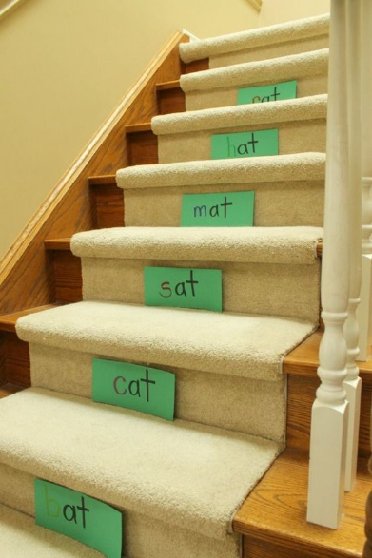  Thursday – Watch the alternative phoneme (sound) for the ‘’oo’ digraph video on tapestry and see if you can join in with the blending video. Watch Geraldine find things around the house https://youtu.be/-3UUnmNk1UM  Friday –High Five Splat! Watch the video on tapestry to see how you play and then have a go yourself!  Repitition is so important in learning. How about putting words with the daily sound all around your home? You don’t need stairs but here is an idea! | Our focus at the moment in maths is teen numbers and deepening our understanding. Although most children can count easily to 20, this does not mean they truly understand the numbers and how they are formed. By spending time on this, it will support them in later years when they have to use this knowledge of number and apply it to other areas.  Monday – Watch the Teen Numbers Lesson 6 video on tapestry focussing on the numbers 19 and 20 then have a go at the suggested activities.  Tuesday – Have a look at the 0 – 20 cards attached in the email. SCROLL DOWN TO THE 0- 20 CARDS. The cards show each number in lots of different ways. Chat about what you can see then choose one number and see how many different ways you can show it! It’s really important that children see a number represented in lots of different ways and also where they might see numbers in their everyday life.  Wednesday – Watch the Teen Numbers Lesson 8 on tapestry. Have a go at building a teen number on your ten frame and identifying one more and one less. Try this with two or three different numbers and talk about what you notice.  Thursday – Spot the mistake! Watch the Teen Numbers Lesson 9 on tapestry. Then have a look at the pictures alongside it. Using what I taught, can you spot the mistake and explain?  Friday – Don’t say 20! To end this week, have a go at this fun game. You need atleast two players. Take turns to say up to three numbers in a row counting to 20. Everyone starts with 3 points, whoever lands on 20 has to take one away! You can use your ten frames to help you with this if you need.

I have attached a phonics spotter story for each of the sounds we are learning this week. You could use these as bedtime reading. Spot the sounds together or ask your child to listen out for them. Perhaps your child could scan the page to see if they can spot them and you can make it into a game. I am not expecting the children to be able to read the text independently although the th phoneme spotter is mostly decodable.
Tricky Words
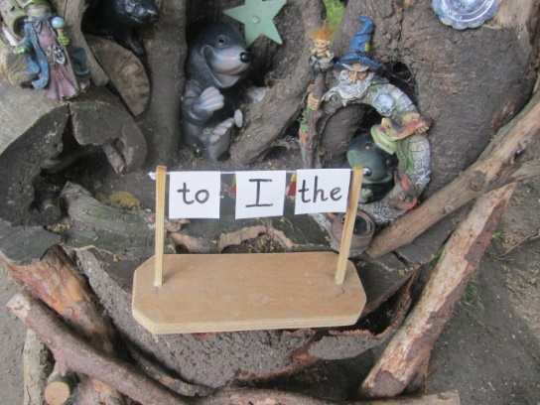
In Giraffe class we learn many ‘tricky words’. Tricky words are words that we can not sound out and we should be able to sight read. They are also common words so learning to spell some early on can really help with our condfidcme in writing. I have attached a document with all of our tricky words on. Have a go at dotting them around the house or making a ‘Tricky Word Washing Line’ of them so the children are quite literally bumping into them everywhere they go!
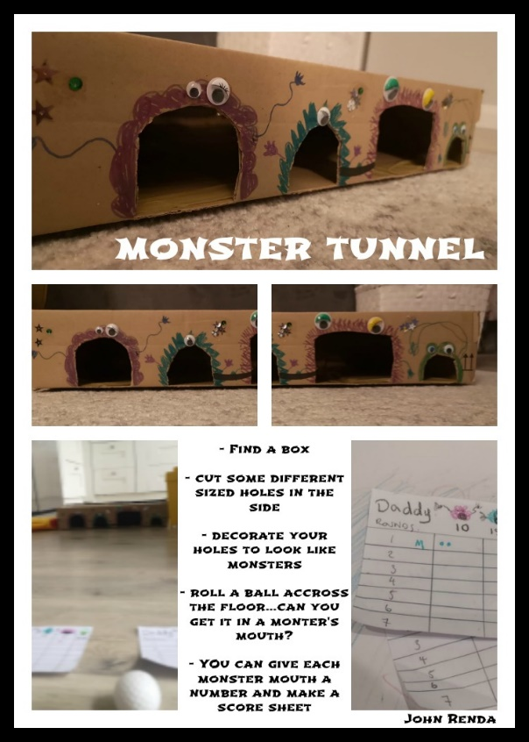
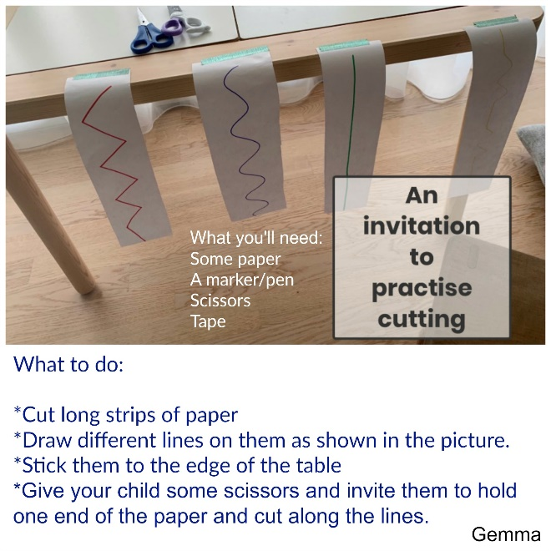
Weekly challenge ideas:
Great for fine motor skill practise. Start nice and easy then gradually increase difficulty. Some children will need to be reminded the correct way to hold scissors.
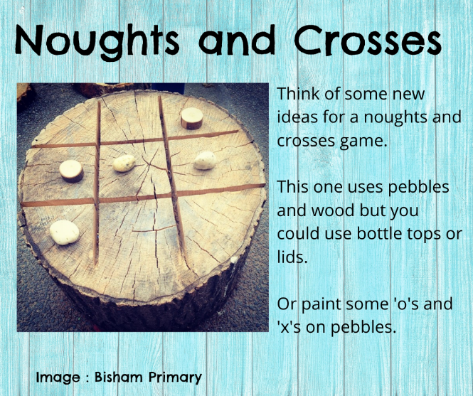
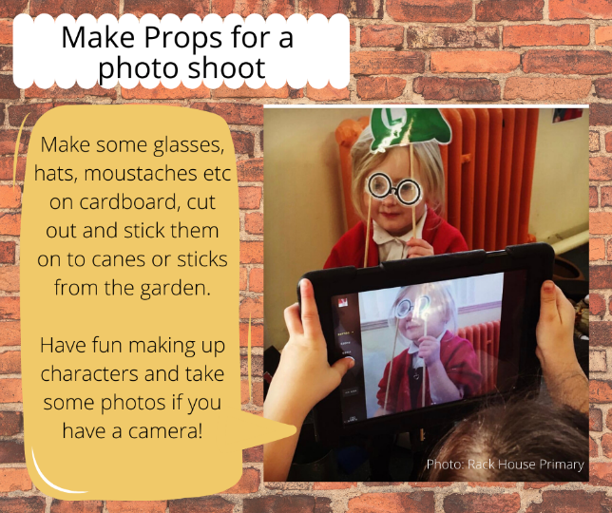
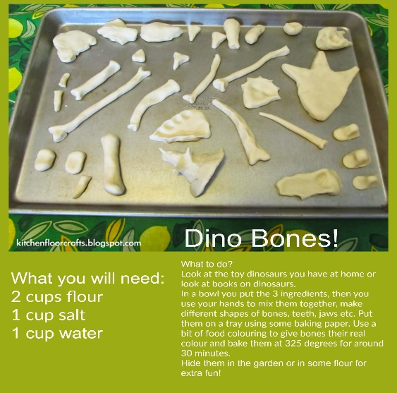

Use your props and your stage to tell a story. This could be one you have heard, a helicopter story you have written, or you can even make it up as you go!
Use the language of ‘Take Turns’ for this activity. Can your child explain why it is important to take turns in a game like this one?
Use the language ‘design’ for this challenge. Explain that to design is to arrange and plan something in a certain way. Can they explore the shape and size of the bones?

Have a go at following these super step by step drawings!
Thank you for everything!
Maisie
https://www.youtube.com/watch?v=7SWvlUd2at8
FREE stories online – https://www.storylineonline.net/

