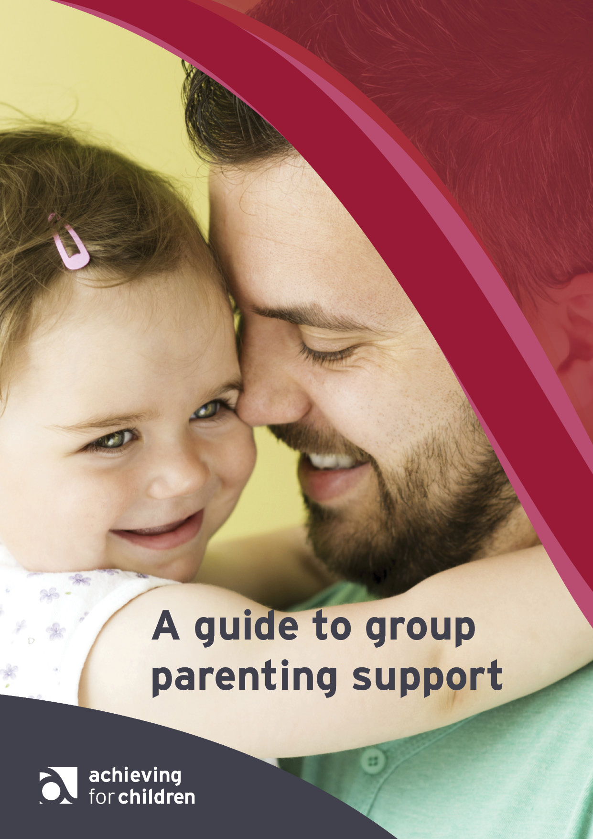
–
Our vision for good parenting in Kingston and Richmond
Parents are the most important influence on their child’s future. We want to ensure that support is available to all parents in Kingston and Richmond who need it to help them and their children achieve the best possible outcomes.
We believe these outcomes will be supported best if all parents in Kingston and Richmond:
- give their children love and attention;
- keep their children kept safe and healthy;
- ensure their children attend school daily and support their learning; and
- teach their children right from wrong and give them clear rules to live by.

Parenting need levels
- Universal
All parents, before any problems may arise.
- Targeted
Parents needing additional support and guidance through self referral or agency identification and referral, focus on spotting early signs of problems and working to prevent them taking hold.
- Specialist
Parents who are vulnerable and/or who have children with complex behaviour problems.

What we offer
Universal
Positive Start: 0 to 5 years of age
A five week parenting course for parents of children under 5 held in children’s centres. Devised by our Family Support Team, it is an introduction to parenting strategies and sessions include child development, parental wellbeing, learning through play, behaviour and positive parenting.
There is input from our Early Years Team with information about the importance of learning through play and parental engagement and interaction.

Family Links Nurturing Programme: 5 to 12 years
Also known as the Parenting Puzzle or Nurturing Programme, this 10 week course provides simple, effective tools to help adults and children:
- understand and manage feelings and behaviour;
- improve relationships at home and in school;
- improve emotional health and wellbeing; and
- develop self-confidence and self-esteem - crucial ingredients for effective parenting and learning.
Adults are given tips on how to:
- build on pre-existing parenting skills;
- use positive behaviour management, communication and relationship strategies; and
- look after their own emotional needs, so they can parent more effectively.
The Nurturing Programme is a universal programme that:
- increases the wellbeing of all families;
- is an effective vehicle for change in vulnerable ones; and
- uses ideas and products developed specifically for the UK.
Group size: 10 to 12 parents
Delivery: 10 weeks, two hour sessions

Positive Parenting: Time Out for Parents – The Teenage Years
A seven week programme for parents of adolescents designed to help parents stay connected with their child through understanding their world and developing good communication skills.
Sharing ideas with other parents is a key part of the course, case studies and real life scenarios are used to help ground the material. Each session includes space to plan any changes parents may want to make in their parenting, and from session 2 there will be an opportunity to discuss how they are getting on with putting this into practice at home.
The course looks at the change from childhood to adolescence and what parents hope to gain from the course. Parents explore how they can meet their child’s emotional needs, taking into account their temperament and their ‘love languages’.
Stepping into their teenager’s shoes and thinking how they can help with the many changes
they're experiencing is next: the challenge is to stay connected! Parents consider their parenting style, its effect on their teenager, and learn about the power of a consistent approach. Encouraging responsibility and negotiating house rules are part of the programme too.
One of the biggest challenges for parents of teenagers is communication. We look at improving it by listening well, using empathy and understanding body language. How we handle conflict is also crucial, choosing your battles, checking out your anger style, and developing negotiation skills.
The final session helps us look at how we unwittingly contribute to negative behaviour by our responses. We also consider the values we want to pass on to our kids and how to build good lasting memories.
Group size: 8 to 12 parents
Delivery: seven weeks, two hour sessions

Time Out for Parents – Handling Anger in the Family
If you have children aged 5-16 years, then Time Out for Parents – Handling Anger in the Family is for you. Over 4 sessions, you will increase your skills and confidence as a parent and discover practical tools to help you and your children deal with the ordinary, everyday anger that all families experience.
The 4 sessions will include Manging our anger and helping children manager anger.
Group size : 8 to 12
Delivery : four weeks, two hour sessions

Time Out for Parents – The Primary Years
Positive Parenting Time Out for Parents courses provide common sense, jargon-free information and ideas to help you to engage with your children and boost your relationship.
Over six sessions you will increase your skills and confidence as a parent and discover practical tools to make your relationship with your child even better.
The sessions:
Session 1 – What being a parent’s really like
Session2 – Children’s needs
Session 3 – Feelings and listening
Session 4 – Boundaries and parenting styles
Session 5 – Keeping children safe
Session 6 – Building strong families

Group Size – 8 to 12 parents
Delivery – six weeks, two hours

Targeted
Incredible Years: age range ideally 3 to 8 years
Facilitated by Educational Psychology Service this 14 week course is for parents of children presenting with challenging behaviour, particularly oppositional and aggressive at home. Incredible Years is suitable for parents of children who have a diagnosis of ADHD as it meets NICE guidelines as a recommended first-response intervention.
Incredible Years is a well researched parenting programme founded on social learning theory.
It aims to identify, intervene, and support families of young children, with behavioural difficulties and promotes parental engagement with children. Methods include practise, DVD segments, modelling, group discussion and homework for parents to try at home the techniques learnt. Practical support is an important element of each group.
Incredible Years promotes positive parenting, improves parent-child relationships, reduces critical and physical discipline, increases the use of positive strategies, help parents to identify social learning theory, principles for managing behaviour, improves home school relationships, promotes child directed play and language through play, increases parent and child self -confidence, promotes praise and encouragement, establishes clear and predictable routines, positive discipline and effective limit setting and managing difficult behaviour.
The aims of the course are to:
- strengthen parenting skills in managing challenging behaviours and promote positive interactions between parent and child
- increase parents’ confidence in promoting children’s social, emotional, physical and learning development
Delivery: 12 to 14 weeks, two hour sessions
Group size: 8 to 15
Homework: Yes

Triple P: For children aged 0 to 12 years

A seven week positive parenting programme which helps you understand the way your family works, and uses the things you already think, feel and say and do in new ways that nurture relationships, parenting skills and confidence, as well as supporting your wellbeing.
Triple P helps you:
- create a stable, supportive, harmonious family environment;
- teach your children the skills they need to get along with others;
- deal positively, consistently and decisively with problem behaviour should it arise;
- encourage behaviour you like;
- develop realistic expectations of your children and yourself; and
- take care of yourself as a parent.

Triple P Teen: For young people transitioning to secondary school to up 18 years
Teen Triple P is a seven week group parenting programme with a focus on helping parents with concerns about their child’s behaviour by attending an intensive training in positive parenting to manage their child’s transition into early adolescence.

Groups are focused on children’s behaviour, with a strong emphasis on developing positive attitudes, skills and behaviour. DVD segments are used to demonstrate positive parenting skills. These skills are then practiced in small groups. Parents receive constructive feedback about their use of skills in an emotionally supportive context. Between sessions, parents complete homework tasks to consolidate their learning from the group sessions. There are also three phone sessions where parents are supported via phone while they implement the methods at home. Key elements of the programme are: coaching your child to problem solve, active listening, quality time and looking after yourself.
The programme is suitable for parents who are motivated about improving their parenting skills and those who have an above basic level of literacy and numeracy skills (or have access to literacy and numeracy support in and outside of the group) to enable them to complete tasks in the group and at home and to enable them to fully benefit from the program.
The aims of the course are to:
- improve parents’ relationships with their teenager;
- reduce problem behaviour; and
- help teenagers minimise or avoid risky situations with peers.
Delivery: seven weeks, four two hourly group sessions, one telephone session or one-to-one meeting, and one initial and one follow-up session.
Group size: 10 to 12 parents

Specialist parenting
1-2-3 Magic Behaviour Management course for parents.
A 5 week course targeted at parents of children aged 2-12 years with a diagnosis of ADHD or who present with challenging behaviour. There will be representation from other partner agencies to offer information to parents, including Parent Partnership (Kids) and Young carers.

The course will include information on "What is ADHD" and also provide simple tools for parents to:
- Control unwanted behaviour
- Encourage appropriate behaviour
- Strengthen your relationship
- Build self esteem

Cygnets: an autism parenting programme
A seven week programme, two and a half hours a week, for parents of children aged 8 to 16 years with autism. Cygnets combines practice strategies and support for parents specifically around autism. The course will look at various aspects of parenting which will include developing parents’ confidence in managing their child’s behaviour, anger management for both parents and young people, improving parental self-esteem, understanding sensory needs, implementing boundaries and learning ways to problem solve with your young person.

Sessions include topics:
- communication
- sensory issues
- understanding and managing behaviour

Early Bird and Early Bird Plus
Referrals and enquiries for Early Bird and Early Bird plus are only accepted from parents. Once parents have expressed an interest in either group, they will be invited to attend an information session. After attending the information session, parents will then be offered a place on the next available group or will be placed on a waiting list.
Early Bird
For parents whose child has received a diagnosis of an autism spectrum disorder (ASD) and is of pre-school age (not yet of statutory school age).

The programme aims to support parents in the period between diagnosis and school placement, empowering and helping them facilitate their child's social communication and appropriate behaviour in their natural environment. It also helps parents to establish good practice in handling their child at an early age.

For Kingston residents, parents should contact Louise Dibble on 020 8547 6265 or email louise.dibble@achievingforchildren.org.uk

For Richmond residents, parents should contact Beth Hitchens on 020 8547 6698 or email beth.hitchens@achievingforchildren.org.uk

Early Bird Plus
Early Bird Plus is for parents whose child has received a later diagnosis of an autism spectrum disorder (ASD), is aged 4 to 8 years and in early years or Key Stage 1 provision.

The programme addresses the needs of home and school settings by training parents and carers together with a professional who is working regularly with their child, the aim being that a child will be given consistent support. We work to build both parents' and professionals' confidence and encourage them to problem solve together.

For Kingston residents, parents should contact Hannah Webber on 020 8547 6659 or email hannah.webber@achievingforchildren.org.uk

For Richmond residents, parents should contact Beth Hitchens on 020 8547 6698 or email beth.hitchens@achievingforchildren.org.uk

General information
We aim to rotate the offer of courses within all the localities. Parents can access any courses regardless of the locality where they live. Parents can self-refer.
Once a referral has been made, the parent will be contacted by phone and text to discuss the referral and to establish which course would be most suitable. Where possible, the referring agency can arrange and fund translators if required and the parent is committed to attending the course.
Where possible we offer crèches but this depends on the location of the course and the target age group. We do not offer crèches for courses for parents of teenagers.
We aim to offer some evening courses but these are mainly for the courses for parents of teenagers.
Staff who currently support the delivery of group parenting courses are from the Early Help teams, children’s centres, youth services, voluntary agencies such as Young Carers and Homestart, school staff and some children’s social care staff.

Contacts
All referrals and requests for additional information for both boroughs should be addressed to karen.williams@achievingforchildren.org.uk

