Giraffes Guidance for Learning at Home
From Week 3 onwards, I will be uploading a short Phonics and Maths video each day. You can choose when you would like to fit them into your timetable but, as before, I have provided an example of a daily routine. As there is a maximum video time on tapestry, the lessons will be general an d then I will provide links and suggestions to the next step in learning to be done independently. This is where activities can be differentiated to your child’s ability.
I will continue to email/call once a week to check in with each family. Please continue to check your emails so that we can keep in touch.
As the period of time away from school extends, tapestry will become essential for me to keep track of progress. I am so grateful for the responses to emails I get and also the involvement with tapestry. Please continue to do this and if you haven’t had the chance to upload yet, please perhaps try and upload a few photos/videos with a comment at the end of the week. If you find this is too difficult with time, then please let me know via email and we can work out a way of sharing home learning.


Writing ideas!
Watch the story on tapestry which I uploaded on Monday. Gorilla LOVES Vanilla.
- Can you listen out for all of the rhyming words?
- What’s your favourite ice cream flavour and why? Have a go at writing a sentence about it.
- Write and illustrate another page for the book. Think about who else might visit the shop and what they might order to eat!

Writing/phonics (for five sessions) | Maths (for five sessions)
- Speedy sounds everyday using flashcards!  Monday – Let’s reflect on our weekends. Watch the tapestry video about what I got up to and then have a go at writing your own sentence and drawing a picture to match!  Tuesday – Watch the ‘ur’ phonics video on tapestry. Choose an ‘ur’ word from the list in the video. Can you write a sentence using that word? Remember your finger spaces and sound mat!  Wednesday – Watch the ‘oi’ video on tapestry. Have a go at Phonics Pop on the link below. Choose the sound of the day and 2 other sounds you have learnt recently. See if you can pop the balloons to get to the next level!  https://www.ictgames.com/phonicsPop/index.html  Thursday – Watch the ‘air’ video on tapestry. Have a go at sound buttoning the words: hair, stair, pair, chair and fair. What do you notice about where the sound is in all of the words?  Friday – Tricky word bingo. Use the tricky words sent out last week to help you with this. Just like we do in Giraffes, draw your bingo board (into six boxes). Choose and write 6 tricky words. Ask your parent to read out tricky words at random and cross them off once your word has been read!  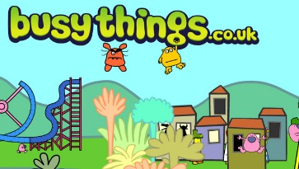  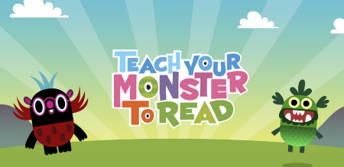  Remember to use these two great apps/sites. | Addition and subtraction. The Early Learning Goal for children in Reception - ‘Using quantities and objects, they add and subtract two single-digit numbers and count on or back to find the answer’.  Monday – Watch the Monday video on tapestry. Using your counting tools and your two ten frames (to make 20), have a go at the addition questions I have uploaded. Using objects is called concrete learning and is vital in supporting a child’s understanding.  Tuesday – Watch the Tuesday video on tapestry. The next step after concrete learning is pictorial. Use the activities attached using pictorial representations to add. If you can’t print, then it’s easy to create your own. Scroll down to page five and you do not have to complete all pages!  Wednesday – Watch the Wednesday video on tapestry. Today we are exploring how addition looks on a number line. Use the number line to have a go at solving the problems!  Thursday – Watch the Thursday video on tapestry. After you have watched, have a go at the game yourself! It’s tricky and if you need to revisit earlier lessons then please do!  Friday – Introducing addition and subtraction into your play. Have a go at creating your own shop. Label some food items like the photos on tapestry. Keep each food item under 10p. Can you buy two items and add up how much they cost altogether?  Next week we will be looking at subtraction and how number facts link!

I have attached a phonics spotter story for each of the sounds we are learning this week. You could use these as bedtime reading. As you read them, see if your child can spot the words with the sound in them.
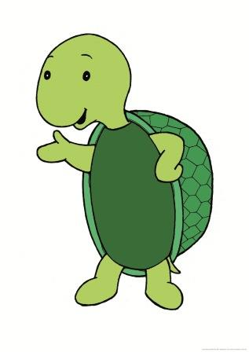
Personal, Social and Emotional development
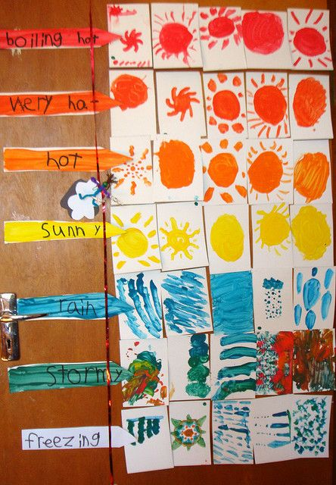
Poems!
Last week you had a little look at rhyming strings. This week have a look at rhyming words in action. I have attached some poems but some of the rhyming words are missing. Can you help work out what they should be?
How are you feeling today?
Do you remember who this is? It’s Twiggle! Twiggle has helped us so much in Giraffe Class to think about our feelings and what to do if we get an uncomfortable feeling. Can you think of a time you have felt worried? Tell an adult and then discuss what made you feel better. Remember it’s very normal to have lots of different feelings, comfortable or uncomfortable.

Weather chart! Have a go at making your own weather chart and have a look at where the arrow should be each day.
What’s your favourite weather and why?
Can you draw a picture of you on a stormy day and you on a hot, dry day? I wonder what’s different about you and the things around you?

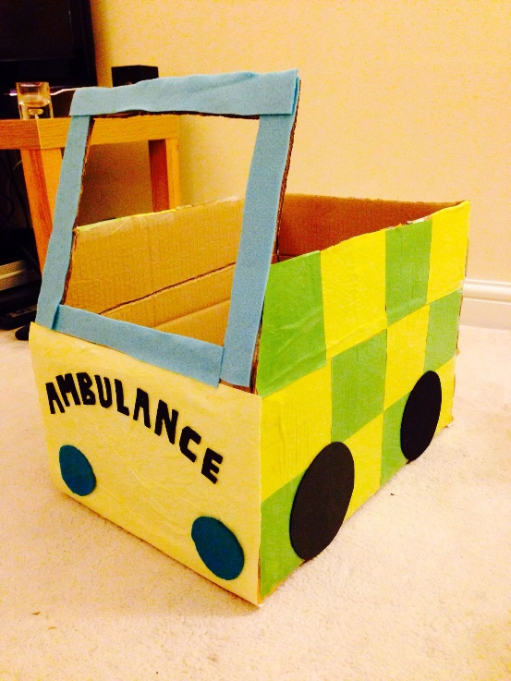
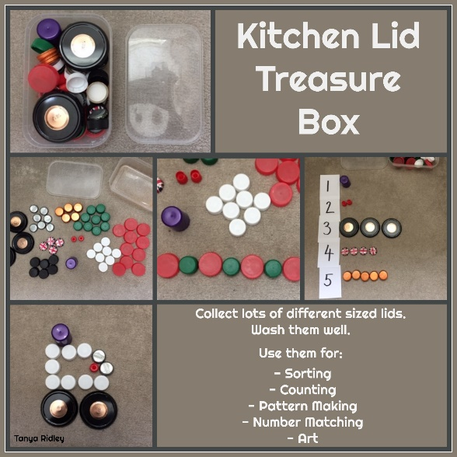
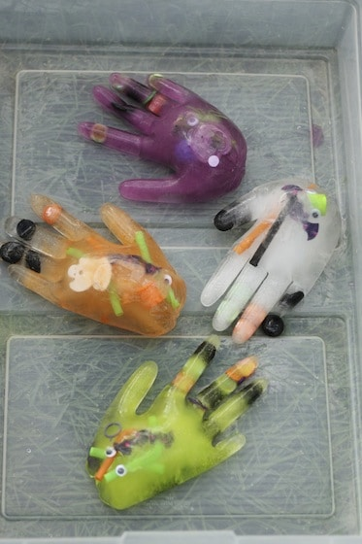

I’ve been collecting bottle lids for Giraffe Class since school closed as they have so many uses and children love them. Have a go at collecting some into a container over the week. Once you have a few, try sorting them and making patterns. Can you make a picture out of them and perhaps draw your own background?

This activity was hidden away in a previous resource pack but after seeing a Giraffe have a go, I thought it was worth sharing again as it looks so fun. Freeze some objects in the hand. Can you work out how to get them out? Discuss how something becomes frozen and how to melt something.

Get creative! Find any cardboard box, no matter how big or small. See where your imagination takes you. Will you build a vehicle? A shop? A castle or a boat? I can’t wait to see your lovely creations. Take your time and come back to it throughout the week.

Thank you for everything!
Maisie
Comprehension – Have a look at the WHY questions attached in the email or on tapestry. Can you look closely at the picture to answer the why questions?

