More PE activities to try at home

#ThisIsPE was created by Yorkshire Sport Foundation (recommended by Department for Education) to support teachers and parents to teach PE at home during the coronavirus lockdown.
#ThisIsPE – Taking part safely
We want every adult and child who takes part in #ThisIsPE to enjoy doing it. Just as importantly, we want you to be safe from injury. #ThisIsPE partners, led by the Association for Physical Education, have put together a few health and safety tips:
- Make that there is enough space around you (including overhead) for the activity you are doing.
- If you can, do ball activities outside. If this is not in a garden, be sure to follow social distancing guidelines by staying two metres away from anyone not from your household.
- Make sure the surface is even and not slippy underfoot.
- Make sure any equipment used is not too heavy or too large for children.
- Ask children to wear appropriate clothing and footwear for the activity - Tie back long hair and remove any jewellery.
- Give your child plenty of opportunity to have breaks during the longer activities, to rest and drink water to stay hydrated.
- Do not work children to exhaustion.
- If you are practising a skill, focus on good technique rather than the amount they can do
You will need a mobile device, laptop or PC to view the videos. The link to the website is:
https://www.yorkshiresport.org/get-active/thisispe/
A new lesson will be added at 1pm on a Monday, Wednesday and Friday. They’ll also be posted on Facebook, Instagram and Twitter, so just find what’s best for you.
Each video will focus on a different aspect of the National Curriculum. The short online videos, delivered by PE teachers, will help to continue your child’s skill development in PE. Videos will be posted at 1pm on a Monday, Wednesday and a Friday. You don’t need to be in PE kit and you don’t need sports equipment. All the videos will use things that you can find around the home.
In order to view all the videos in one place, they’ve created a #ThisIsPE YouTube playlist. The link is:

https://www.youtube.com/playlist?list=PLYGRaluWWTojV3An2WEgsQ4qGFy_91jDL
This is what the website looks like. If you click where it says Click here for the notes to support each video, it gives detailed instructions on each activity. I don’t think these are needed as most of the videos are straightforward and you/your child should hopefully be able to work out what to do.
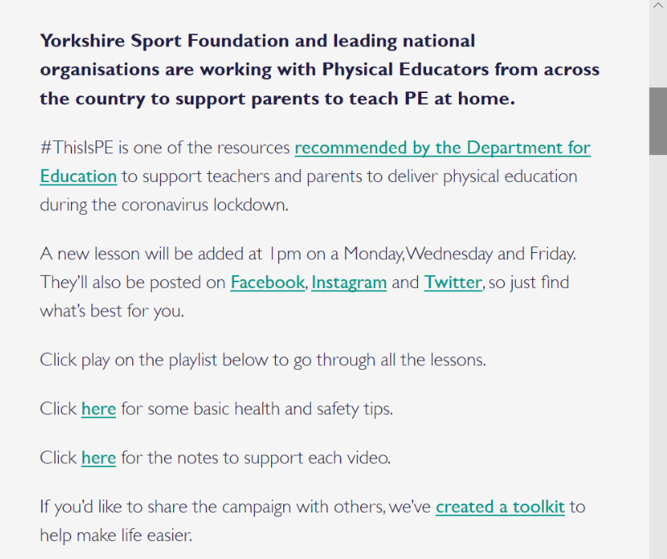

Click here where it says click here for the notes to support each video

This is the screen which shows where to click for YouTube playlist link:
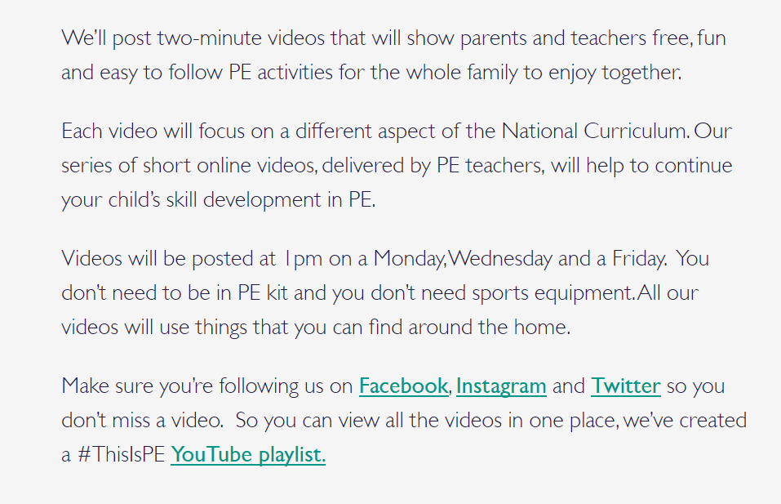

Click on link where it says YouTube playlist

For each activity/drill you will need the following items:
Co-ordination with Ball skills – 2 or more rackets (tennis or badminton) and balls (ideally soft – foam or rubber). If no rackets/balls can use a large hardback book and a scrunched-up piece of paper for the ball; a long sock or piece of string/tape etc to make ‘net’
Footwork patterns – several ‘obstacles’ – cones if you have them, if not anything like soft toys, plastic cups, socks, things to make posts for competitive game – items of clothing work well
Throwing for accuracy – different sized boxes, soft balls/toys/bean-bags/rolled up socks or other soft objects for throwing

Rocking and rolling – you ideally need to do this on a soft surface e.g. carpeted floor, a mat if you have one, grass in your garden. You’ll need a towel to lie on, long (sports) socks, pair of socks rolled together. This is quite advanced at the end but will appeal to all those budding gymnasts (of which there are many!).
Balloon blasting – two or three different coloured blown-up balloons
Jumping combinations – ties, rolled up tea-towels and socks. You could include some arts and crafts here and make some feet out of paper and card – you could get your child to draw round his/her feet and then cut them out. Please supervise the cutting. Could also draw round the parent/carer’s feet.
Agility – you will need a bit more space for this one so ideally should be done in your garden if you have one or at the park (remember social distancing guidelines). You will need some obstacles – you can use anything from around your house or garden such as soft toys, plastic buckets, cones, socks, shoes, toys etc. You will also need some soft balls.
King of the cones – you will need a bit more space for this one so ideally should be done in your garden if you have one or at the park (remember social distancing guidelines). You will need a variety of balls but preferably soft such as tennis balls and some cones (about 8) or anything that can be used as a target e.g. soft toy. There is room for creativity here.
Fast feet / Agility – you will need a bit more space for this one so ideally should be done in your garden if you have one or at the park (remember social distancing guidelines). You will need a series of soft objects e.g. socks/soft toys and something to make a line e.g. tie, some kind of ball e.g. football. May be good for you to have 2 sets of equipment to avoid collisions.

