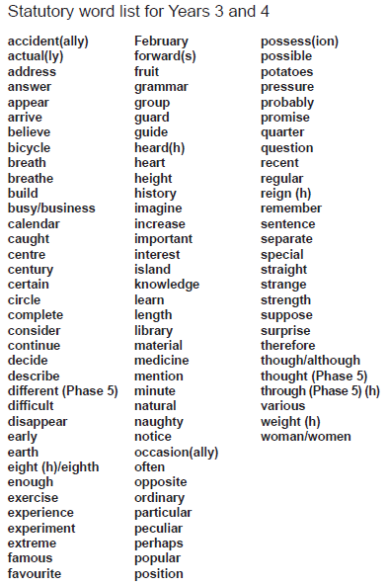
Here is a reminder of the Year 4 statutory spellings. Please ensure you are continuing to practise these weekly as well as using them in your writing when you can. I have included some strategies to help you learn to spell these words as everyone will prefer a different way. I have always been a fan of the segmentation strategy and pyramid words. Which one works best for you? See if you can try them all!



