English – Letter Writing
This week I would like you to work on writing a letter... to me! It has been over a year since I was last your teacher. The last time I saw you was before the Easter holidays when you were Monkeys, I bet that feels like ages ago! I always loved hearing your news and all the exciting things you were getting up to (in and out of school) and I am sure that so much has happened in a year and I want to hear all about it. Each day you will work on a different skill of informal letter writing to ensure that you produce the best letter you can. If you want to send your letter to me (maybe ask someone to take a picture of your letter and email it to me) then I would love to see your work and read all your news.
If I wasn’t your teacher last year because you have joined the school since then, I still want to hear your news! You can also tell me about yourself so I can get to know you better for when I meet you.

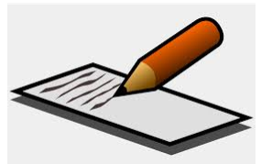

In your writing at home, remember to consider your success criteria. Remember to always use neat, joined handwriting. Sentences should almost always be complete with capital letters and the correct form of punctuation.

It might be helpful to refer to our target sheets here: http://www.kewriverside.richmond.sch.uk/page/?title=English+%2D+Writing&pid=1552

Hold yourself to your highest standard and have fun!
Monday
LO: To deconstruct an exemplar text
Read the example letter written by Jane to her Mum. Think about which features Jane has used in her writing to produce her letter. Using the checklist below, deconstruct the text by highlighting the features you see in the letter. Choose a different colour for each one. I have left 2 empty boxes for you if you find any new features.
Extension: Which part of Jane’s letter do you find to be the most powerful and why? Which feature has she used successfully to create an engaging letter?

Feature | Highlight
Senders address and date
Recipient’s name at start and senders at end
Introduction
Questions to the reader
Capitals for proper nouns
Noun phrases
Fronted adverbials
Writing organised into paragraphs
Suffix words spelt correctly
Homophone words spelt correctly
Tuesday
LO: To create a mind map
When you are writing your final letter to me, you are going to be including information about what has happened to you over the last year. A year is a long time! I probably don’t need to know about your last haircut or when you ate some fish and chips! I would however love to hear about any achievements in and out of school – certificates, medals, awards, trophies. If you have moved house, decorated your bedroom or got a new pet would be something I’d love to hear about. What has been your favourite topic so far in crocodiles? Did you reach any targets in your learning that you are particularly proud of?
Create a mind map to help you organise and prioritise your thoughts. You can create a spider diagram, draw pictures and label them – whatever works for you. You can then look back at this and pick the best parts you want to form into sentences. This is just a planning activity of your thoughts so don’t worry too much about presentation, the ideas matter more. Get a giant piece of paper or type it up on the computer, the choice is yours!
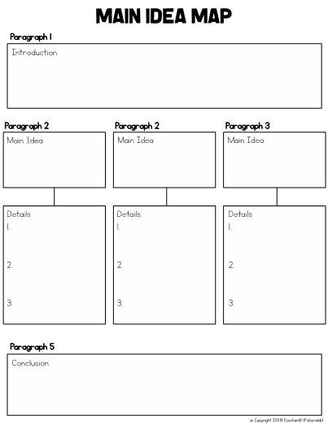
Here are some examples which might inspire you:
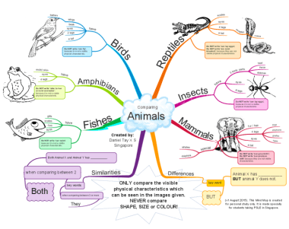
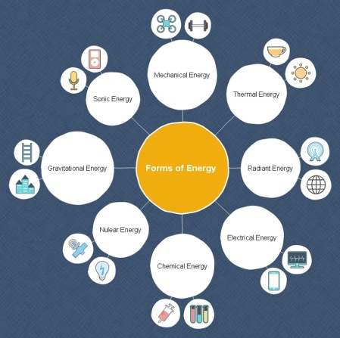
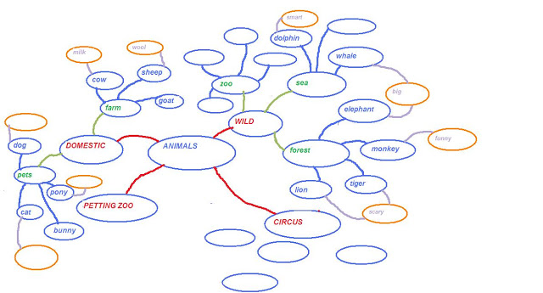
Wednesday
LO: To plan your letter from your mind map
Using the mind map you made yesterday, start to think about how these ideas can join together into sentences and paragraphs.
Looking at Jane’s letter again, think about how she started her letter and created an introduction. How did she then form her ideas clearly into paragraphs before having an ending and signing off?
You may want to edit your mind map and only include some of your ideas or you may be able to see how more than one idea is around the same topic i.e. ‘achievements’ and that these can be combined into the same paragraph.
Create your own paragraph planner like the one below:

Thursday
LO: To write an informal letter
It’s time to write your letter to me! Make sure to use your mind maps, paragraph plan and Jane’s example letter – these are all there to help you. Refer back to the ‘Feature / Highlight’ table from Monday to ensure you are including the features needed for informal letter writing.
There is also a ‘letter writing word mat’ to refer to which would be helpful to have next to you as you work.
Think about your presentation, spellings and punctuation.
It might be helpful to refer to our target sheets here: http://www.kewriverside.richmond.sch.uk/page/?title=English+%2D+Writing&pid=1552
I know you have been working on fronted adverbials with Holly. This is one of the features that Jane uses in her letter to her Mum and would be great for you to include in your letters to be. Can you include 3 sentences which start with a fronted adverbial? Here are a couple reminders of what makes a fronted adverbial:
https://www.youtube.com/watch?v=mKoKCi9Cfb0
https://www.theschoolrun.com/what-are-fronted-adverbials
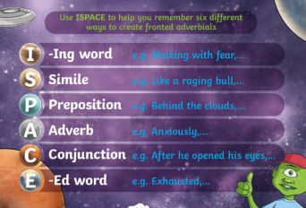

Friday
LO: To proof read and edit your informal letter
Read over your letter from yesterday and correct or edit as you go along. Scan for spelling and punctuation mistakes as you read. If you’re not sure if a word has been spelt correctly then you can always use a dictionary to double check.
Think about the vocabulary and word choices you have used. Have you used the most interesting and exciting language or could some words be improved? You can use an online thesaurus here to help: https://www.thesaurus.com/
Remember to use the ‘Feature / Highlight’ table from Monday and look back at this to make sure you have all of these features in your letter. If there is one missing then you can edit your letter and include it now. If it is just a small piece of information missing which you would like me to know, this can always be added to your letter as a PS.
Once you have proof read and edited your letter and are happy with it ask an adult to take a photograph or scan it in and send it to me. This is not compulsory but I would love to read your letters and hear all your news.
If you would like to add any drawings to your letter then I would be happy to see these too.

