Art
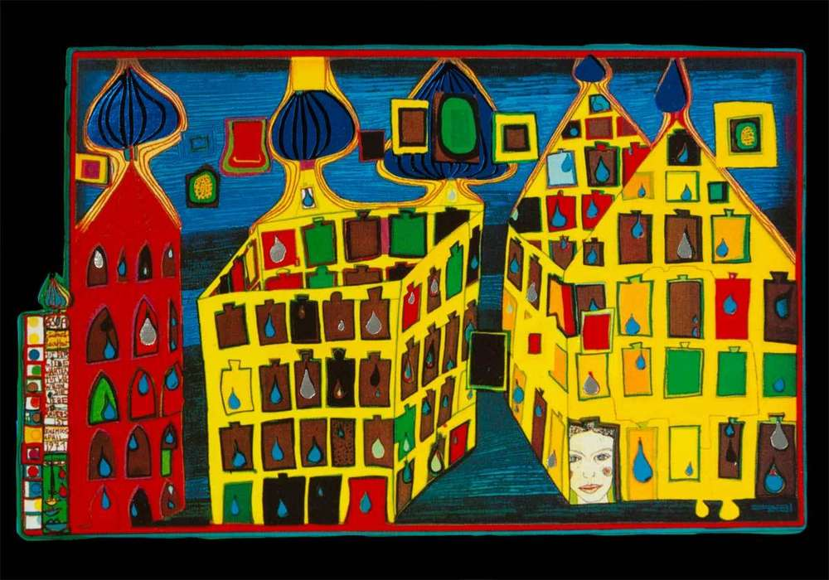
In school we were learning about the artists Maggi Hambling and Friedensreich Hundertwasser. Choose one of them, and paint your own picture in their style. Hundertwasser’s style would also work well on Microsoft paint if you don’t have paint at home, as he uses lots of shapes and solid colours.
Hundertwasser:
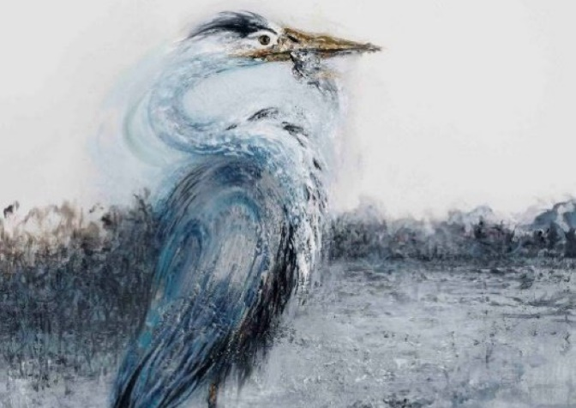

Hambling:


