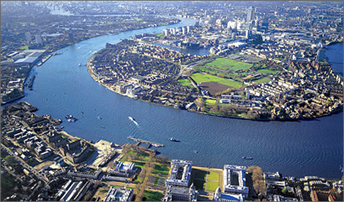
Sequence:
Session 1 – Research River Thames
Session 2 – Plan Writing
Session 3 – Write Fact-File

Writing Task – Using Non-Fiction Features
We have already started finding out lots of information about the River Thames, from its starting point in Kemble all the way out to the North Sea! Your writing task for the week is to plan/research, write and edit a fact file about The River Thames.

LO: To use non-fiction features in my writing.

Remember to include:
- Title
- Sub-headings
- Pictures
- Captions
- Fact-boxes
- Diagrams

In your book, write the date and LO then split your page into 6 boxes, research each area in the first session. In the second session, plan your fact file using the 6 boxes. In the final session, you will be ready to write.
See the example of the plan on the next page. I have put some questions in red that you may wish to include.

Example of how to layout your non-fiction report on page 3.
LO: To research and select appropriate information.
Geography of the River  Where does the river start?  What towns does it pass through?  How does the river change?  Which sea does it flow out to? | What is it used for?  Who uses the river?  Why do they use it in different ways?  Has the use of the river changed over time?  What do people use the river for in Kew?  What wildlife live by/in/on the river?
History of the River  What did people used to use it for?  How was it important during historic times?  How has the River usage changed throughout history? | Fun Facts
Famous Bridges  What are the most famous bridges that cross them?  Why are they famous?  Which is the oldest/newest bridge? | The Future of River Thames  What issues is the river facing?  How can people help?  What problems are there with plastic pollution?

LO: To use non-fiction features in my writing.


