
Email address: info@kewriverside.richmond.sch.uk Tel: Tel No: 020 8487 8437

Focus of the Week:
Be Kind
Key Dates coming up
 |  |  | Giraffe and Zebra Class | Barnes Literacy Festival
16th May | Zebra and Elephant parents | KS1 Phonics Screening Check Information Evening 6pm
20th to 24th May | Lion Class | PGL Osmington Bay
21st June | Whole School | Sports Day

NEWSLETTER
10th May 2019 Issue 30

Golden Certificate Winners this week
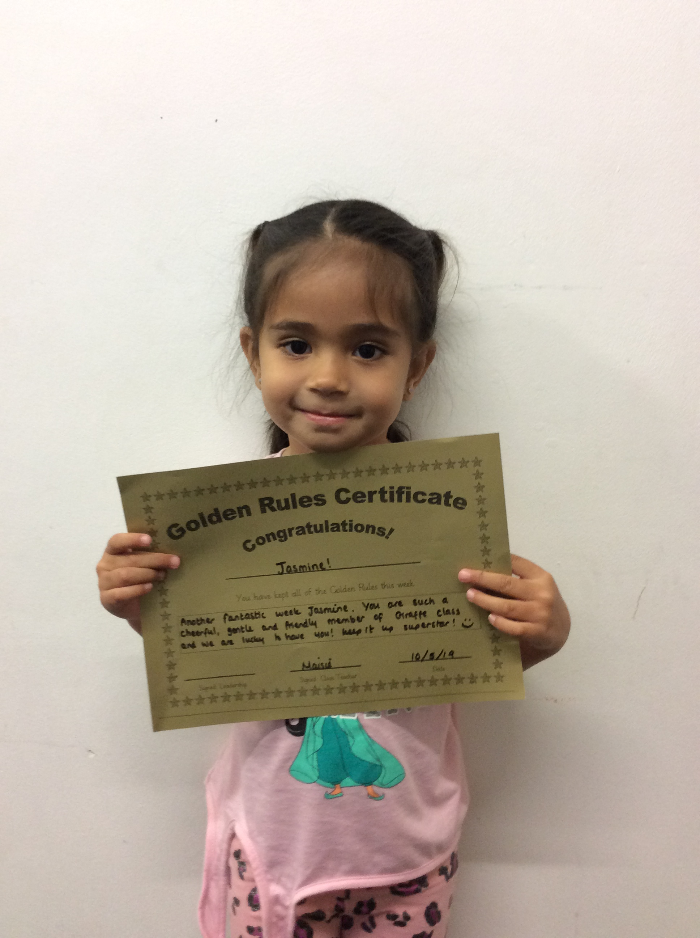
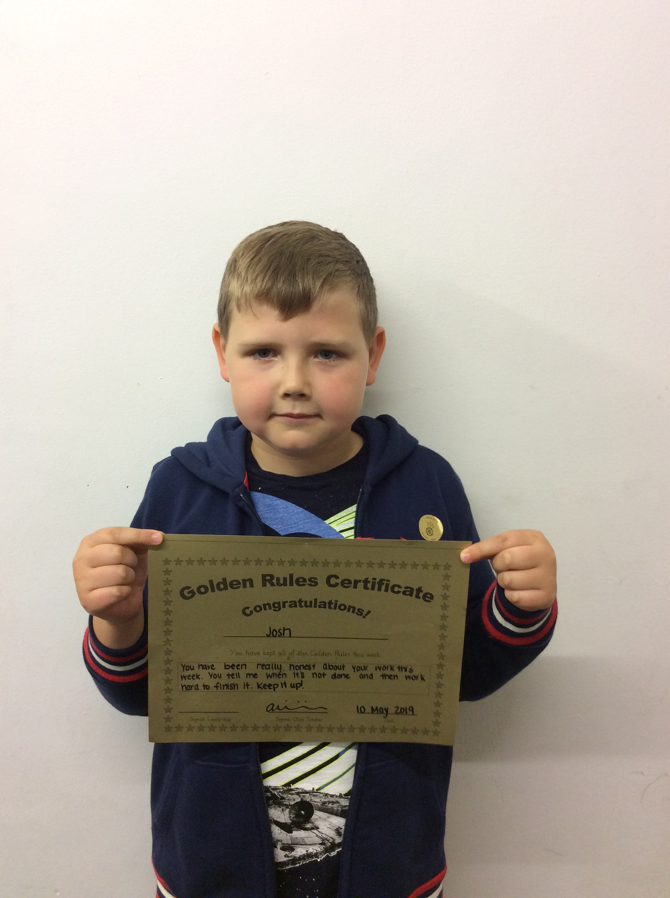
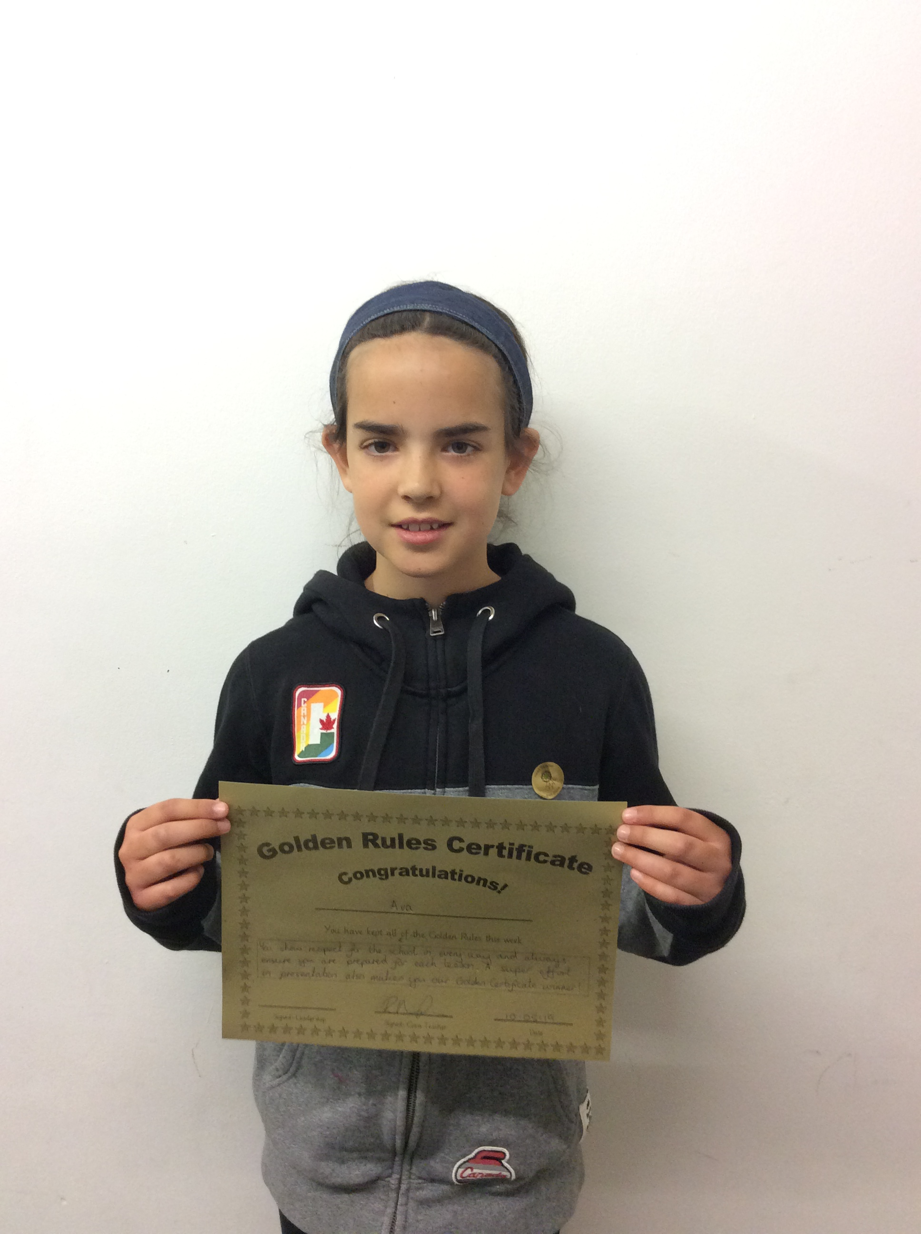
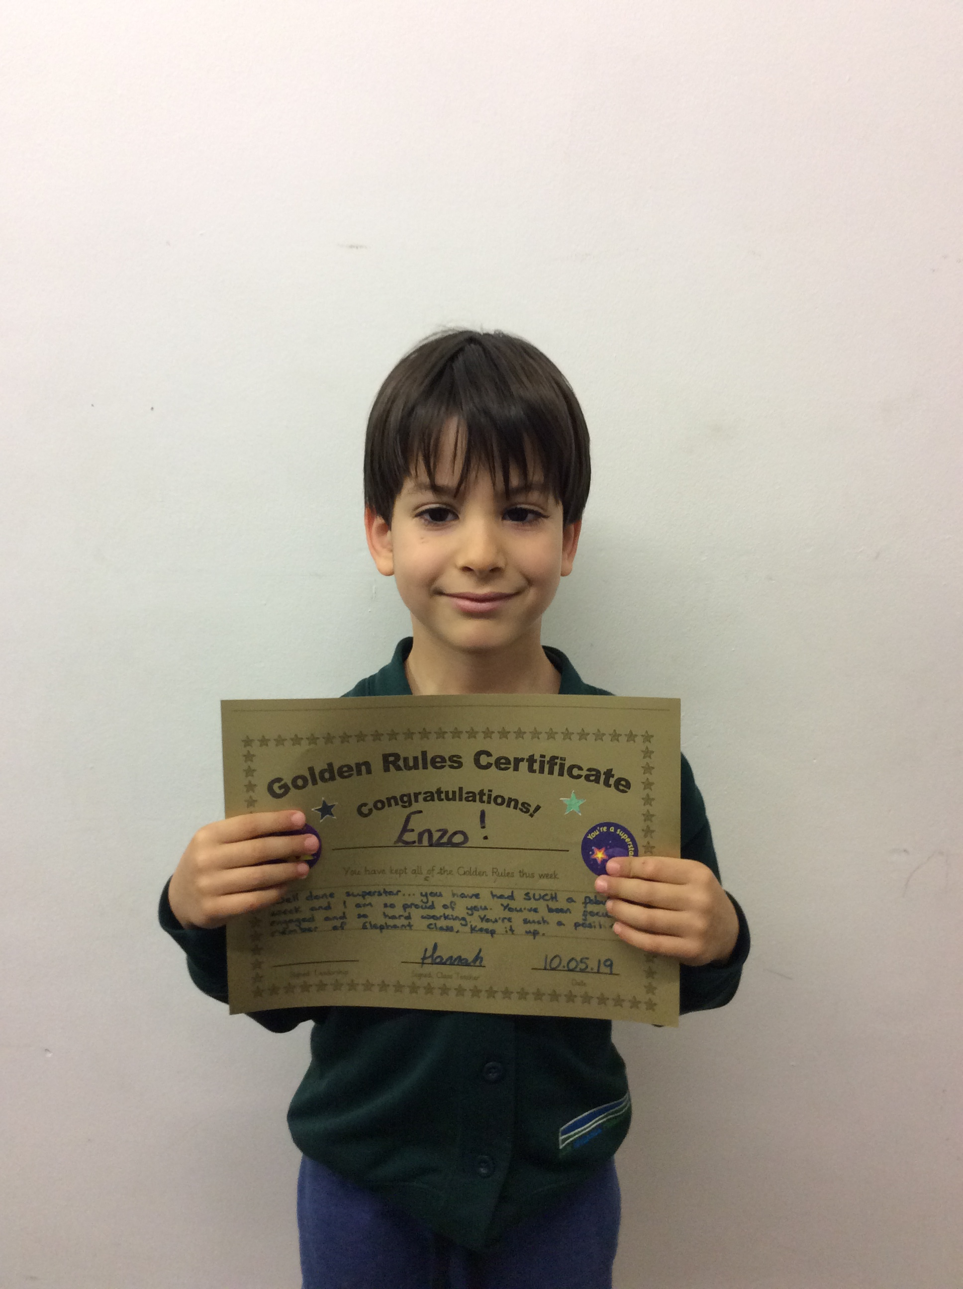
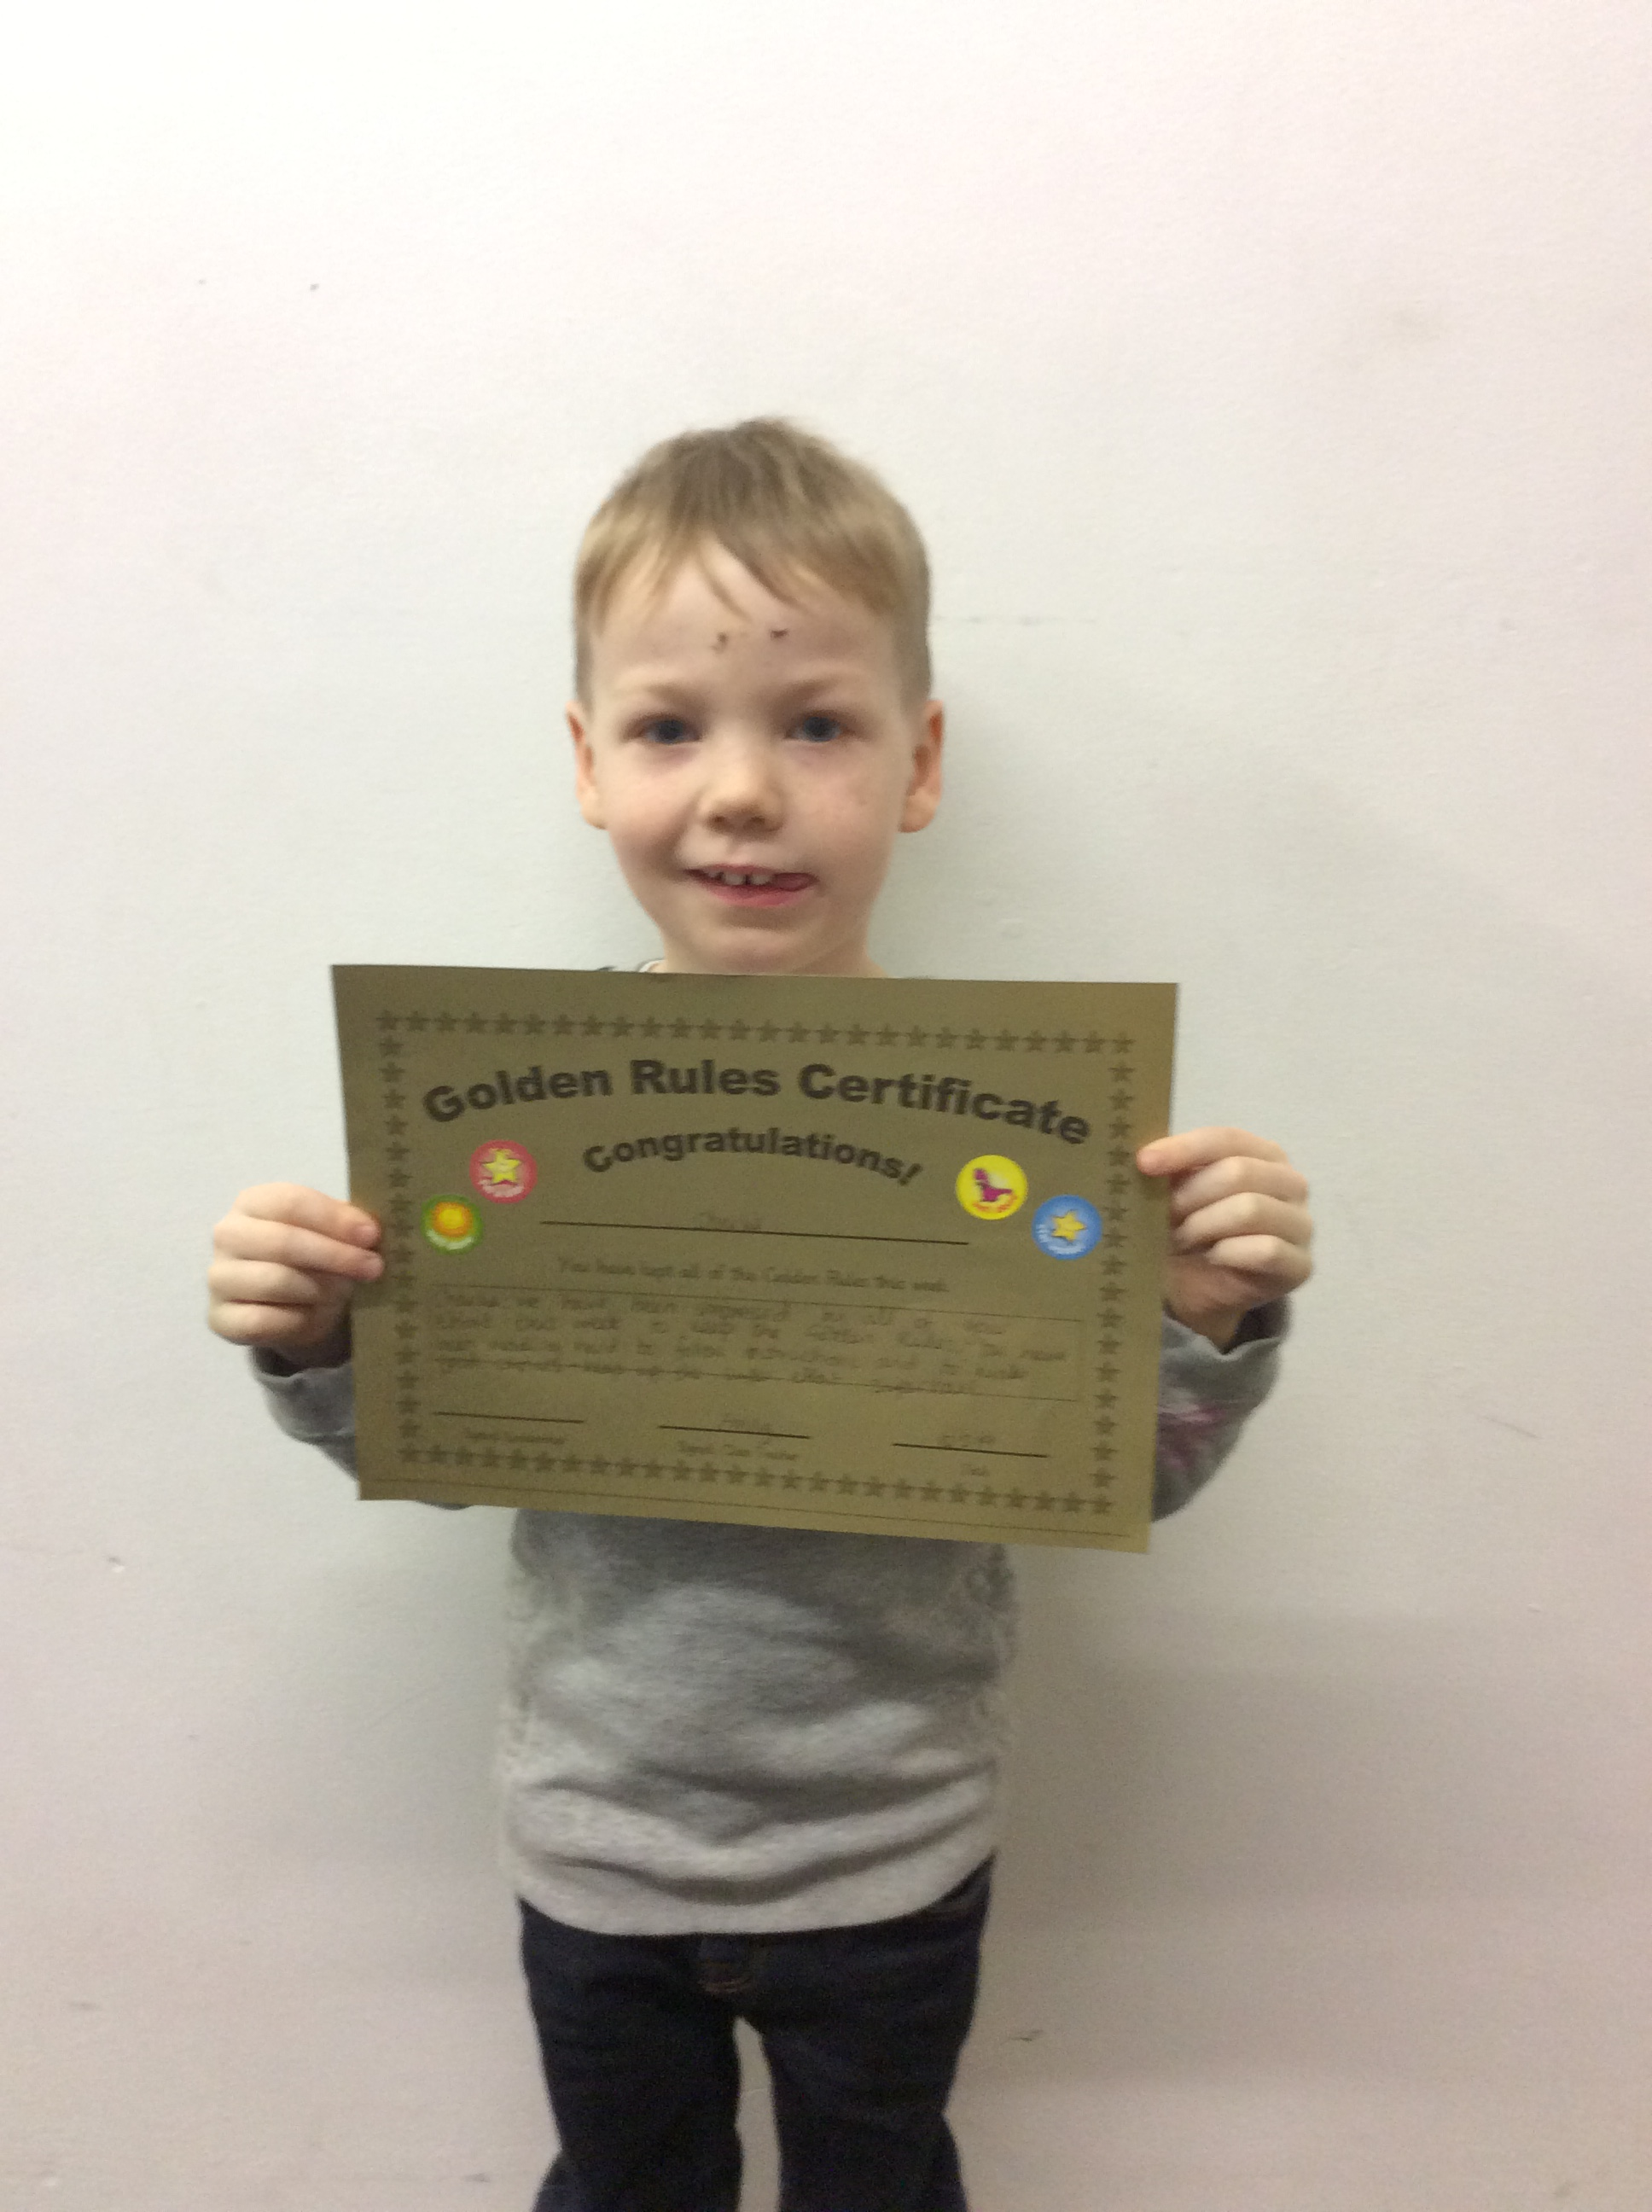
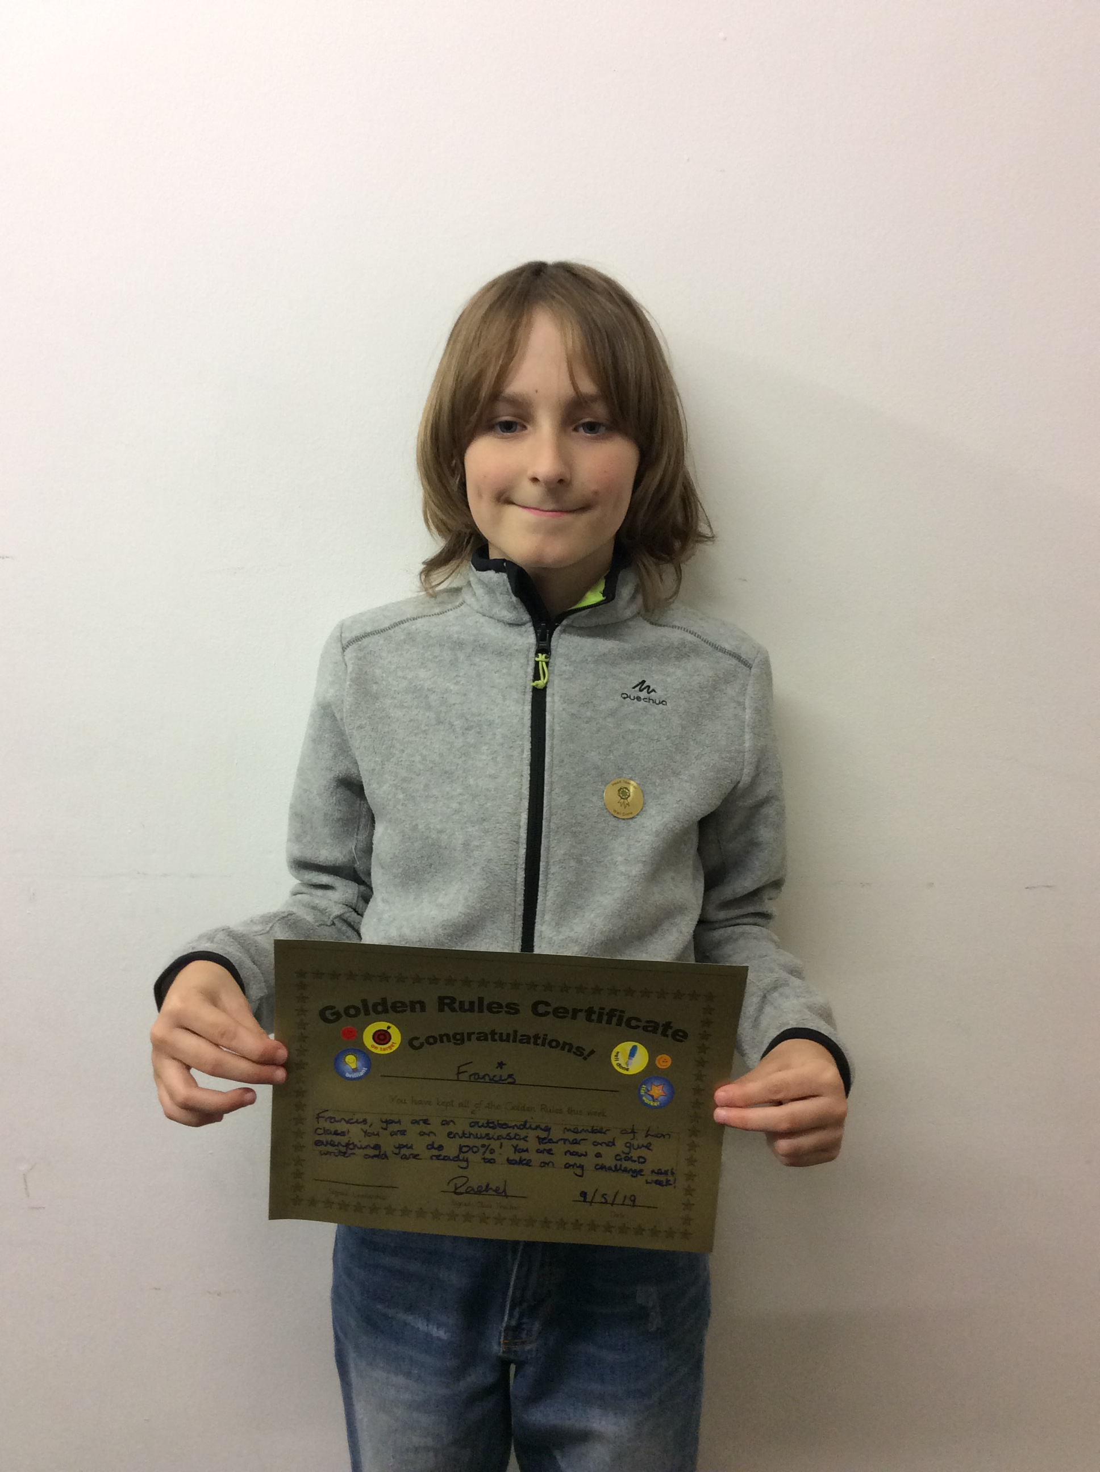

Dear Parents and Carers

May Fair 2019
As I write, preparations are underway for this year’s May Fair. As ever, the PTA has worked tirelessly to produce a lovely event to kick-off the summer and boost the school’s coffers. On behalf of the staff, I would like to thank all of those who have given their time and donations to make the fair such a great event. See you there!

Scooters and Bikes
It is such a positive that so many children come to school on bikes and scooters. However, the children must dismount on entry to the school site. We would also ask you to keep any toddlers off their scooters in the playground. As this is not the first time this message has gone out, I expect the children to comply! This is about safety, so please reinforce this message to your child. Thank you.

Message from Rachel
Dear all parents! It’s that time of year when we will once again be calling upon your expertise for the Summer Production. Any help with the scenery and/or prop making would be greatly appreciated. Please speak to either myself or Roxanne if you are interested. Any contributions of: large cardboard boxes, tins and old fabric would also be gratefully received. Thank you so much!

New Uniform – Summer Hats
Our wonderful new floppy ‘cricket’ style summer hats will be part of the school uniform from September. If you would like to purchase a hat for your child now, they are available online via Scopay at £5 each.

The Kew-Oxford Thames Path Trek 2019 – A message from Mark Williams

The Kew Riverside Ramble 2019

At the time of writing (Thursday morning) together we have raised £750 for PTA funds.

I would like to thank everyone who donated for their generosity in getting behind my walk along the Thames Path, and for smashing the initial fundraising target that I set.

I also want to thank those who have sent me messages online over the past week, as well as the many people who have come up to me to offer their kind words and congratulations I have greatly appreciated all of your support, encouragement and goodwill. Knowing that people were taking such an interest really helped me through. It speaks volumes about our school community and the fabulously positive energy that there is among us.

So all the very best to everyone. And here’s to the next Kew Riverside adventure!

Mark.

Response from KRPS
Congratulations Mark and a massive thank you from all the staff, children and parents for this fundraising effort. Much appreciated and for a fantastic cause – the support of the OAK program!

Continued Appeal – Donations from ‘Nature’
We are still looking for donations of ‘natural’ objects to spark children enquiry and curiousity for the ‘Wild Cabin’ – for example, abandoned wasps nests, honeycomb, shells, small succulents/cacti, dried starfish, animal skeletons, fossils, fir cones, seeds, leaves, old etchings of minibeasts, identification posters, etc. Please leave donations with Lisa at the school office.

We have had lovely shells and children-sized garden equipment donated already. We will have soil and compost delivered next week for the planting beds and will begin to kit-out and decorate the cabin and den soon!

Have a fantastic May Fair and weekend!

Darren

The School Development Plan (SDP) and Self Evaluation Form (SEF)‬‬‬‬‬‬‬‬‬‬‬‬‬‬‬‬‬‬‬‬‬‬‬‬‬‬‬‬‬‬‬‬‬‬‬‬‬‬‬‬‬‬‬‬‬‬‬‬‬‬‬‬‬‬‬‬‬‬‬‬‬‬‬‬‬‬‬‬‬‬‬‬‬‬‬‬‬‬‬‬‬‬‬‬‬‬‬‬‬‬‬‬‬‬‬‬‬‬‬
Please refer to the link below to see our progress against the School Development Plan 2018-19.
http://www.kewriverside.richmond.sch.uk/page/?title=School+Development+Plan+%28SDP%29+%26amp%3B+Self+Evaluation+Form+%28SEF%29&pid=149

Governors
If you have any questions for or about the Governors please send them to: governors@kewriverside.sch.richmond.uk

Weekly Maths and Word Challenge for Children & Parents
http://www.kewriverside.richmond.sch.uk/page/?pid=1398&action=saved

Community Events
Please visit this link for more community events
Parent courses
Key Stage 1 (Giraffe, Zebra & Elephant)

Giraffes:

Zebras:
KS1 Phonics Screening Check Information Evening
On Thursday 16th May at 6.00pm there will be a Phonics Screening information evening for current Year 1 parents and parents of children in Year 2 who will also complete the check this year. This will be an opportunity for us to explain the format of the check, how we administer this in our school and for you to ask any questions. Please sign up in the office if you are able to attend.​

Elephants:
KS1 Phonics Screening Check Information Evening (see above)

Key Stage 2 (Monkey, Crocodile, Rhino & Lion)

Monkeys:

Crocodiles
Juniper Hall 18th September to 20th September 2019, this is the residential trip for your child when they join Rhino Class in the autumn.

Rhinos
Summer Production 3rd and 4th July
Dear all parents! It’s that time of year when we will once again be calling upon your expertise for the Summer Production. Any help with the scenery and/or prop making would be greatly appreciated. Please speak to either Roxanne or Rachel if you are interested. Any contributions of: cardboard (the bigger the better), tins and old fabric would also be gratefully received. Thank you so much! Lion and Rhino Class.

Lions
PGL Osmington Bay 20th - 24th May
Summer Production 3rd and 4th July - see the information above.
KRPS PTA Committee
Join Classlist Today
KRPS PTA is introducing a new system called Classlist to enable parents to communicate easily with you and each other and allow you to RSVP, volunteer and purchase PTA event tickets online. Classlist’s system offers high levels of security and privacy, and is designed to comply fully with new data protection regulations. You will shortly receive an invitation from your Class Rep, and can then decide whether to join and what data you would like to share. If you don’t wish to receive this invitation please let your Class Rep know within 10 days of receipt of this notice. More information is available at www.classlist.com including the Privacy Notice, which explains how personal information is managed and protected. You can also join Classlist immediately and start enjoying the benefits now. Simply register at www.classlist.com or download the app.

Join Easyfundraising to raise money for KRPS PTA
Thanks to everyone who has already signed up with easyfundraising – we’re really grateful. Over £2,200 has been raised for KRPS PTA through Easyfundraising so far and that’s with only 55 supporters. Imagine what we could do with the WHOLE SCHOOL behind us!

If you haven’t signed up yet, please do it today at https://www.easyfundraising.org.uk/causes/krps/. It only take a few minutes and is a really simple way to raise money for Kew Riverside Primary School through your everyday online shopping with over 3,600 retailers like Amazon, Sainsbury’s, Boden and Argos and it’s completely free! Try it out when buying the kids summer uniforms.


—————

Thank you
KRPS PTA Committee

All parents and carers are automatically part of Kew Riverside's PTA and being involved in any way you can is a great way to meet new people and raise money for our fantastic school. We have regular meetings and are always planning the next event so if you can help in any way or have some great fundraising ideas then please talk to your class reps.
Lots of great events happening throughout the year and we all look forward to seeing you and your families getting involved!




