Unit 1: Counting and Estimating |  |  | SPRING Understanding Number: Unit 1, Exploring and Playing
Play Activity 1: Construction – Lego™ 20s
Aims:  To count to 20 and write this number. | You will need: bricks or cubes; Post-it notes™; pens
Preparation: Set up cubes or bricks in baskets on the table and use cardboard mats for children to build on. Have some Post-it notes™ around the table and a basket of pens.
What to do:  - Children build a model using no more than 20 cubes or bricks.  - Once finished building, they count the bricks/cubes again and choose a Post-it note™ to label the number used. |  | 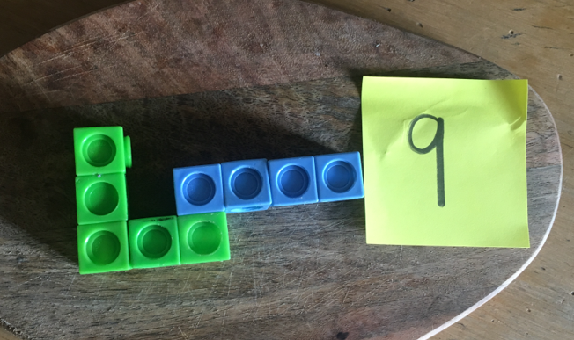
Talking points  - Can you take away a cube/brick each time and count backwards as you do so?  - How many would you have if you added one more cube? How about if you took one cube away?  - Can you build another model with more cubes/ less cubes? | Evidence of learning:  Listen to children talking. Can they count the cubes/ bricks, moving or pointing to each one?  Observe children. Do they miss out any numbers? Could they count backwards or above 20?
Outcomes: I can count up to 20 objects. I can record matching numerals.
I can begin to count backwards.

Unit 1: Counting and Estimating |  |  |  | SPRING Understanding Number: Unit 1, Exploring and Playing
Play Activity 2: Painting stripes
Aims:  To count to 12 and beyond with confidence. |  | You will need: wiggly snakes drawn on A3 paper; paint; brushes; water
Preparation: Draw a wiggly snake on A3 paper and make copies. Provide different coloured paint, thick brushes on the table and water.
What to do:  - Children pick a snake outline.  - They choose different coloured paint to add exactly 12 stripes to the body of their snake.  - Encourage them to count as they go along and re-count when they change colours.  - When they have finished, they count the stripes again to make sure they have exactly 12.  - Some children can do 15 stripes, or maybe 20? |  |  | 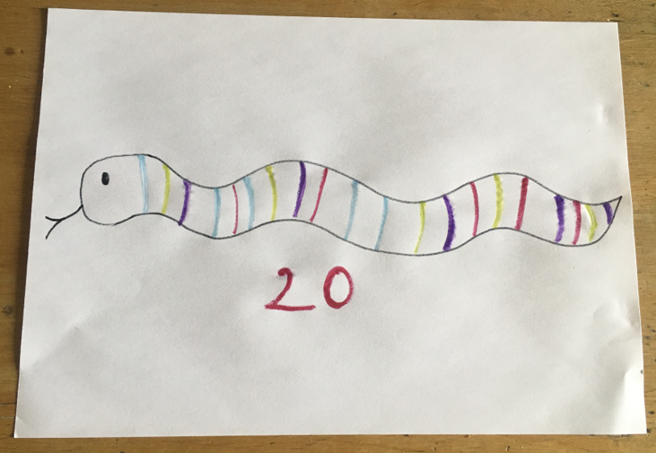
Talking points  - How many stripes have you got so far?  - Do you need to add more stripes?  - How many blue stripes are there? How many red stripes?  - Which colour have you used the most? | Evidence of learning:  Listen to children talking. Can they count the numbers in the right order as they paint them?  Observe children. Do they know how many stripes they have already added? Do they know when they have reached 12?
Outcomes: I can accurately count to 12 and beyond.
I can say whether I need to add more or less to reach 12.

Unit 1: Counting and Estimating |  |  | SPRING Understanding Number: Unit 1, Exploring and Playing
Play Activity 3: Outside numbers
Aims:  To write numerals 1-10 and count actions to that amount. | You will need: big chalk or large paintbrushes with water
Preparation: If using paint brushes, place large containers of water around the playground
What to do:  - Outside, give children large chalks or chunky brushes and water.  - Children write the numbers 1-10 in really big writing on the playground or outside space.  - They then stand on a number and choose an action to carry out that many times, e.g. jumping, hopping, flapping wings (arms), clapping or turning. |  | 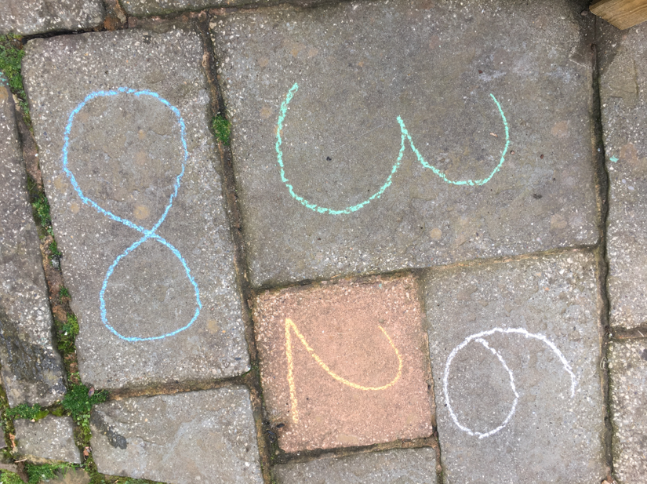
Talking points  - Can you check if you have written the number the correct way?  - Can you stand on a number and say it?  - Can you jump to a number bigger than the one you are standing on?  - How many more jumps will you have to do on this new number? | Evidence of learning:  Listen to children talking. Can they say the number they have landed on?  Observe children. Do they clap, jump, turn the correct number to match the numeral they are standing on?  Do they choose a variety of numbers?
Outcomes: I can write and recognise numerals up to 10.
I can match a number of actions to a written numeral.

Unit 1: Counting and Estimating |  |  |  | SPRING Understanding Number: Unit 1, Exploring and Playing
Play Activity 4: Fine motor skills counting
Aims:  To recognise numbers 1-20 and count objects accurately. | You will need: plastic cups; Post-its™; tweezers; small counting objects e.g. shells, gems, small stones, tiny beads, etc.
Preparation: Place lots of plastic cups on the table. Write a number 1-20 on a Post-it™ and fold this over so it is hidden. Place at least 20 of a variety of counting objects in bowls.
What to do:  - Children choose a cup and unfold the Post-it™ to reveal the hidden number. They say the number.  - They choose a set of counting objects and count that many into the cup. They can use tweezers for this. Then they count them back out of the cup.  - They repeat, choosing a new cup with a new number. |  |  | 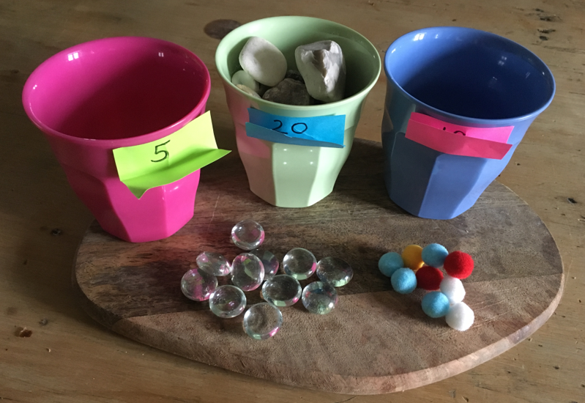
Talking points  - How many have you put in your cup?  - Do you need to add more gems to reach the number on the side?  - Have you got the same number when you counted backwards? This is a good way of checking! |  | Evidence of learning:  Listen to children talking. Can they count matching one to one? Can they count backwards?  Observe children. Do they recognise the numbers? Do they pick just one object as they count?
Outcomes: I can count to 20 and back accurately. I can begin to recognise numbers 1-20.

Understanding Number Unit 1
Counting and Estimating
Exploring and Playing
Teacher Notes

You will need:
- Lego™ bricks or cubes; Post-its™; pens; wiggly snakes drawn on A3 paper; paint; brushes; water; big chalk or large paintbrushes with water; plastic cups; tweezers; variety of small counting objects e.g. shells, small stones, gems, small beads, etc.

KEY CONCEPTS
- Counting forward and back: Children need lots of practice at counting forwards and backwards to recognise the patterns. This then leads on to knowing which number is one more and one less. Children need to have experiences at counting physical objects that can be moved as well as things that cannot be moved such as sounds, jumps, turns, etc.
- One to one correspondence: This is a key concept, which can take a lot of practice. Children need to make sure they point or move an object each time they say a new number in order to count accurately.
- Estimating: Comparing sets and numbers. Being able to make sensible estimates of small numbers of objects. First, they say whether a set is more or less than a given number, before becoming more accurate with their estimation.
- Subitising: It is really good if children are able to say ‘how many’ without counting when the set is 4, 5 or 6.

Watch out for children who:
- struggle to count accurately by pointing or moving the object each time;
- have difficulty with matching the amount they have counted to the numeral or action.
- struggle to compare sets of objects or struggle knowing which sets might have fewer or more.
Support them by:
- Encouraging lots of counting, showing them how to do this in an efficient way, e.g. moving the objects into a line, listening and putting a finger up each time there is a beat.
- Keeping the number of objects small at this stage until these skills have been secured.

