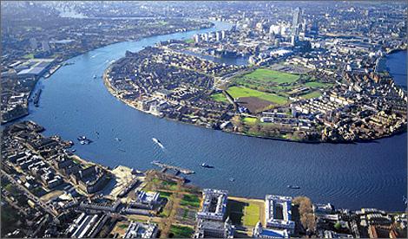
Sequence:
Session 1 – Research Bridges
Session 2 – Plan your Bridge
Session 3 – Make your Bridge

Topic Tasks – The River Thames
We have already started finding out lots of information about the River Thames, from its starting point in Kemble all the way out to the North Sea! Your task for the week is to design, create and evaluate a new pedestrian bridge that will cross the River Thames between Kew Bridge and Chiswick Bridge. You will need to also design a poster to tell the local citizens when it is going to open.

Design Brief:
- Your bridge is only for pedestrians
- It needs to attract wildlife
- Have areas for sitting

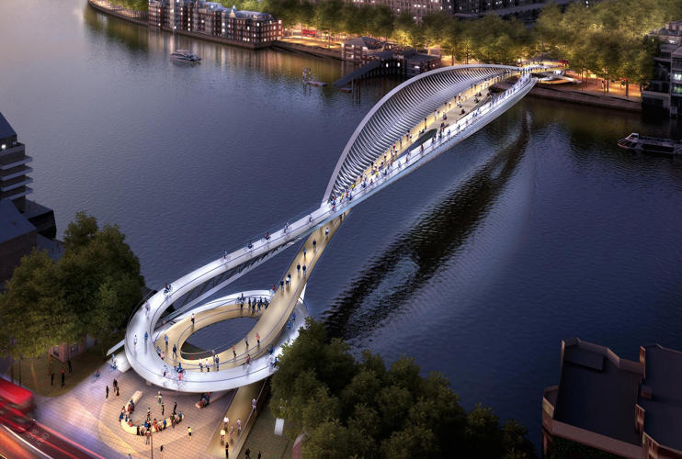
Research some famous bridges for ideas and use your own too.
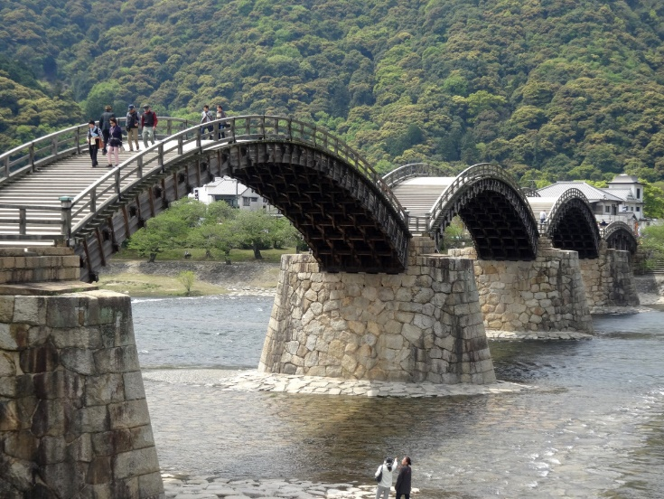

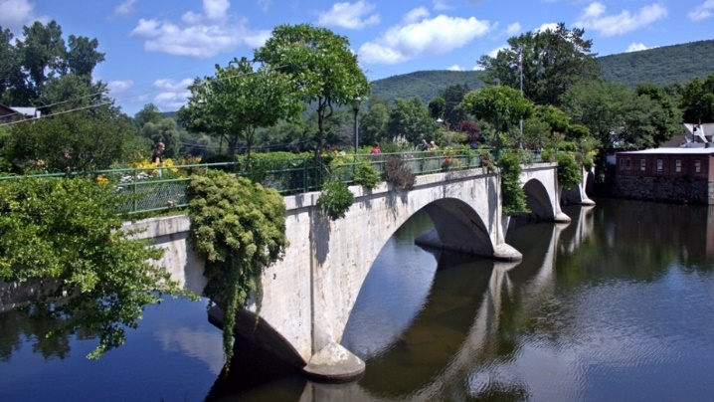

My Bridge will be called:
Materials needed to build my bridge prototype:

My bridge will look like this:

Evaluation:
What did you find tricky when making your bridge? How would you do it differently? Does your bridge look like your design?

