Giraffes Guidance for Learning at Home
From Week 3 onwards, I will be uploading a short Phonics and Maths video each day. You can choose when you would like to fit them into your timetable but, as before, I have provided an example of a daily routine. As there is a maximum video time on tapestry, the lessons will be general an d then I will provide links and suggestions to the next step in learning to be done independently. This is where activities can be differentiated to your child’s ability.
I will continue to email/call once a week to check in with each family. Please continue to check your emails so that we can keep in touch.
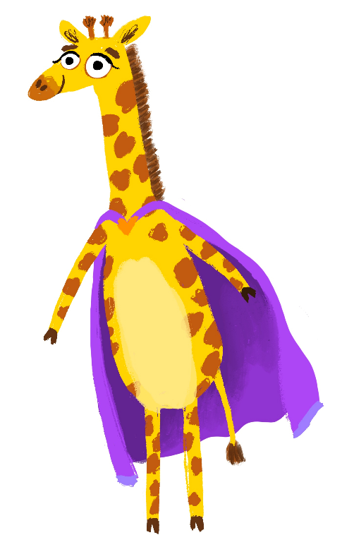
As the period of time away from school extends, tapestry will become essential for me to keep track of progress. I am so grateful for the responses to emails I get and also the involvement with tapestry. Please continue to do this and if you haven’t had the chance to upload yet, please perhaps try and upload a few photos/videos with a comment at the end of the week. If you find this is too difficult with time, then please let me know via email and we can work out a way of sharing home learning.

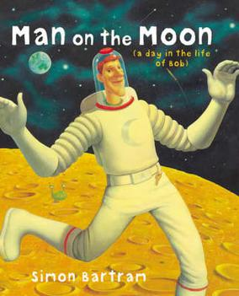
Book of the week!
Watch the video of Lauren on tapestry
reading Man on the Moon and then
have a go at some of the suggested
activities.

Have a look at my message to see who this is!

Writing/phonics (for five sessions) | Maths (for five sessions)
- Speedy sounds everyday using flashcards!  Monday – Watch the video on tapestry and see below about the Time Capsule activity.  Tuesday – Watch the phonics video on tapestry looking at one of the ‘th’ sounds. This sound has two phonemes (sounds) but only one grapheme (way it is written). Have a go at the Roll and Read attached for the voiceless ‘th’.  Wednesday – Watch the phonics video on tapestry looking at the other phoneme of ‘th’. Then have a go at the This or That activity sheet (you don’t need to print – just use as a guide).  Thursday – Watch the phonics video on tapestry looking at the phoneme ‘ng’. Have a go at drawing your own aliens again and giving them funny made up names with the ‘ng’ sound in, for example, Pling. I loved seeing them on tapestry when you did this before!  Friday – Lots of you are still really enjoying the roll it then read it challenges. This week for your tricky words, have a go at the activity attached on tapestry.  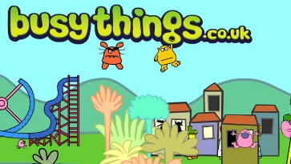  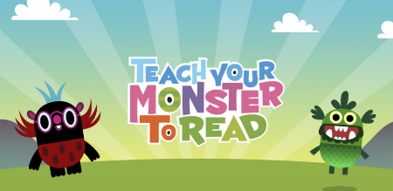  Remember to use these two great apps/sites. | Addition and subtraction. The Early Learning Goal for children in Reception - ‘Using quantities and objects, they add and subtract two single-digit numbers and count on or back to find the answer’.  Monday – Subtracting. Watch the video on tapestry where model how to subtract using practical objects. Have a go yourself. What’s different to when you add numbers together?  Tuesday – Watch the video on tapestry. Today we will focus on how subtracting looks using pictures. Once you’ve watched the video, have a go at the sheet attached on tapestry. Choose your own difficulty level.  Wednesday – Watch the video on tapestry. Today we will focus on how subtracting looks on a number line and how we can use our ability to count backwards to find the answers. Have a go at the questions on the board using your own number line.  Thursday – We use subtraction all the time in everyday life. Watch the video on tapestry to learn about when we might need to use it and then have a go at the subtraction number stories.  Friday – Now that you have recapped your different subtraction skills, have a go at the subtraction booklet attached. You don’t need to do them all, pick the ones you like the look of! You could always teach one of your toys how to subtract!

I have attached a phonics spotter story for each of the sounds we are learning this week. You could use these as bedtime reading. As you read them, see if your child can spot the words with the sound in them.
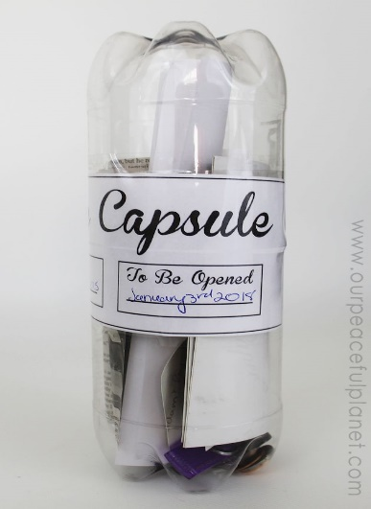
Create a Time Capsule!
Although it is a strange time at that moment during lockdown, it is a time that you will remember for the rest of your life. You will look back at this time and remember what it was like for you; we call this a memory. During unfamiliar times, it can be a good idea to make a Time Capsule which you come back and look at in a few years’ time. Have a go at making your own. You may want to include some pictures you drew during lockdown, a message to yourself in 5 years’ time, a list of your favourite activities when you were at home. Some people even add physical objects like a significant toy or a photo.
Watch our videos on tapestry to see what Christina, Lauren and I would put into our Time Capsules!
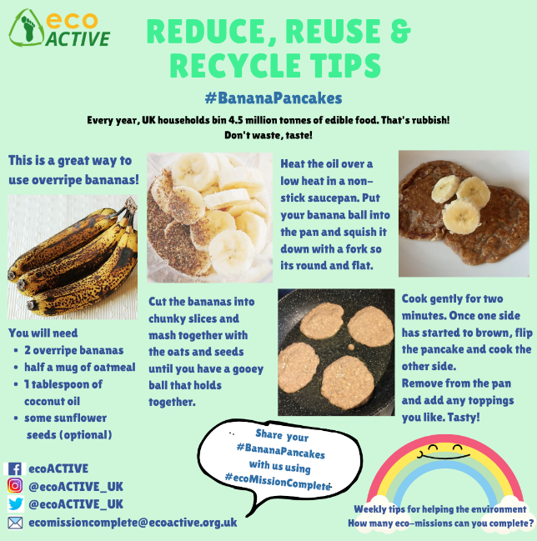
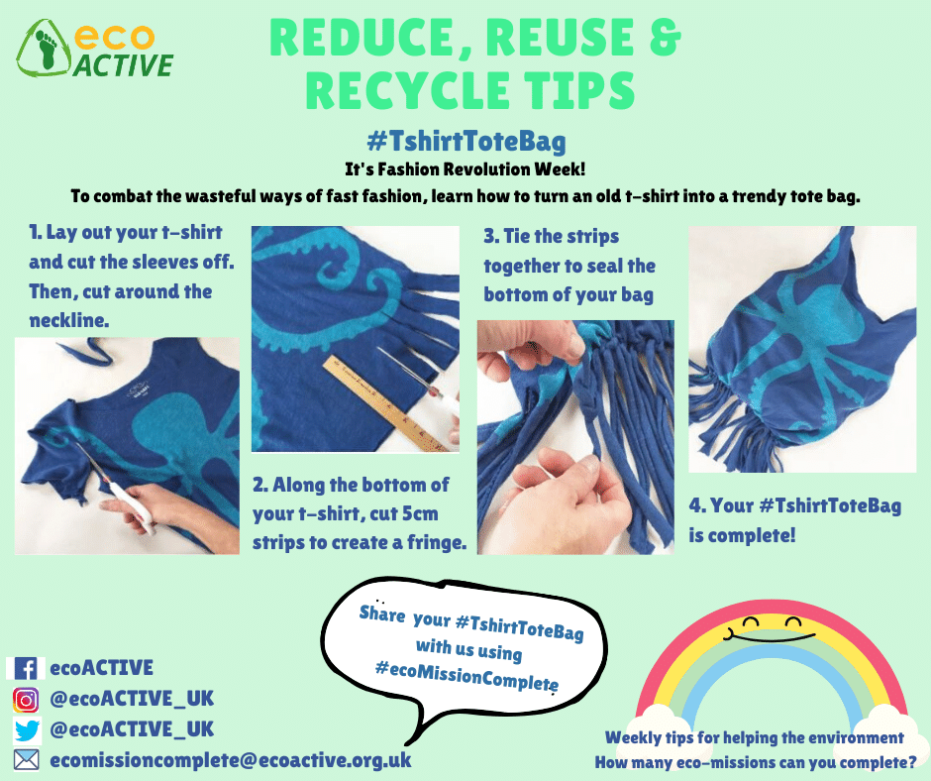
Weekly challenge ideas:
Giraffe Class have shown such an interest in recycling, reusing and reducing waster this year. We have spent time looking at ways to save water and to recycle the things we don’t want or need anymore. This week, have a go at some of these ideas!
Thank you for everything!
Maisie

