Giraffes Guidance for Learning at Home
From Week 3 onwards, I will be uploading a short Phonics and Maths video each day. You can choose when you would like to fit them into your timetable but, as before, I have provided an example of a daily routine. As there is a maximum video time on tapestry, the lessons will be general an d then I will provide links and suggestions to the next step in learning to be done independently. This is where activities can be differentiated to your child’s ability.
I will continue to email/call once a week to check in with each family. Please continue to check your emails so that we can keep in touch.
PLEASE NOTE – The daily maths and phonics videos will change and progress each day. If your child finds a particular lesson challenging, then please repeat that for as many days in a row as you need. In class, I often change plans on a daily basis based on how well the children are understanding. There is no need to keep up with the new daily teaching, it is much more important to understand before moving on. If you need any support with this, then please email me.
Communication and Language ideas!
One of the most crucial areas of development in Early Years is the ability to listen, pay attention and communicate with those around them. Use these ideas for 15 minutes a day (minimum) of talk time.
- Using the Helicopter link I sent out last week, have a go at telling and writing your own!
- Go through the photograph album or look at picture online – sequence those pictures in age order to begin an understanding of chronology.
- With lots of discussion, draw a picture map of your home. You can use words like ‘left, right, just beside, behind, etc.’
- Spot the difference! Another brilliant way to promote focus and language is through spot the difference activities. Please have a go at some of the ones I have attached. I wonder how many differences you’ll see?
Writing challenge! Have a go at making and writing your own postcard to send to someone. It could be a family member or a friend. I wonder what you will tell them about your time at home? Perhaps you have some questions you want to ask? I’d love to see your writing on tapestry!
Writing/phonics (for five sessions) | Maths (for five sessions)
- Speedy sounds everyday using flashcards!  Monday – Watch ‘ar’ digraph video on tapestry and see if you can join in with the blending video. Choose any of the ‘ar’ words and have a go at writing your own sentence!  Tuesday – Watch ‘or’ digraph video on tapestry and see if you can join in with the blending video. Have a go at the ‘or’ roll and read attached. You can have as many goes as you like!  Wednesday – Watch ‘ow’ digraph video on tapestry and see if you can join in with the blending video. Can you write some flashcards with ow words on them? Ask and adult to hide them around your home. If you get the word correct when you find it, you can keep the card – if not, then it gets hidden again! (Words: cow, now, how, clown, down, frown, brown)  Thursday – Phase 3 Tricky Word Scavenger Hunt! Use the attachment to remind yourself of all the tricky words we have learnt so far. Can you have a go at the scavenger hunt?  Friday – Bank Holiday  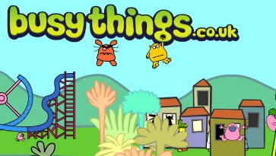  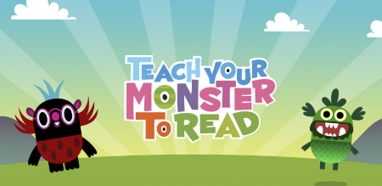  Remember to use these two great apps/sites. | Addition and subtraction. The Early Learning Goal for children in Reception - ‘Using quantities and objects, they add and subtract two single-digit numbers and count on or back to find the answer’.  This week we will focus in depth on number bonds to five before moving onto to addition and subtraction using and tow 1-digit numbers.  Monday – Introducing ZERO! Understanding that 0 is the absence of something is a really important skill. Watch the introduction video on tapestry and have a look at the activities that come with it.  Tuesday – Number bonds to five! Watch the video on tapestry. Find five (‘throwable’) objects and a bowl/bucket. Have a go at throwing them into the bucket. How many went in? How many went outside? Think about how you can record that on a part-part whole to show a number bond to 5!  Wednesday – Number bonds to five! Watch the video on tapestry as we learn different representations of 5. Have a go at some problem solving!  Thursday – Please check tapestry for the activity set for your child.  Friday – Bank Holiday!

I have attached a phonics spotter story for each of the sounds we are learning this week. You could use these as bedtime reading. As you read them, see if your child can spot the words with the sound in them.
Rhyming
Rhyme is a really important aspect of children’s learning. Rhyming and repetition helps children to recognise sounds and patterns in words. Have a go at some of the rhyming strings attached. Or you could follow the link below if you prefer an interactive game.
Draw focus to the end of the words and spotting the similarities.
http://www.literactive.com/Download/live.asp?swf=story_files/washing_line_rhyme_US.swf

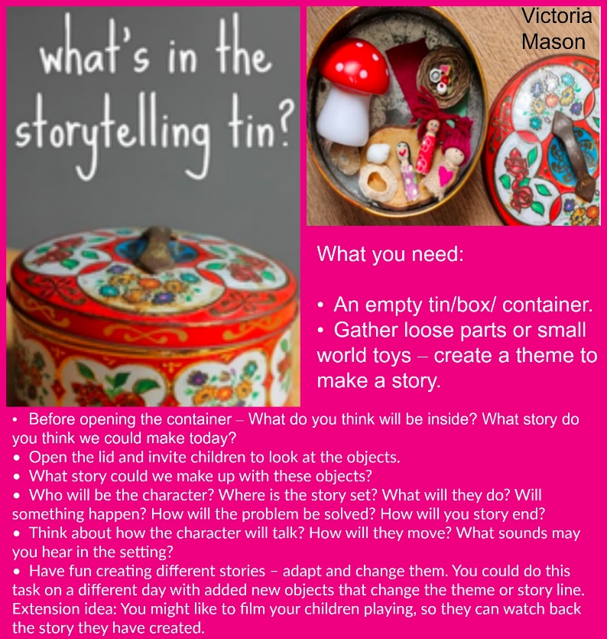
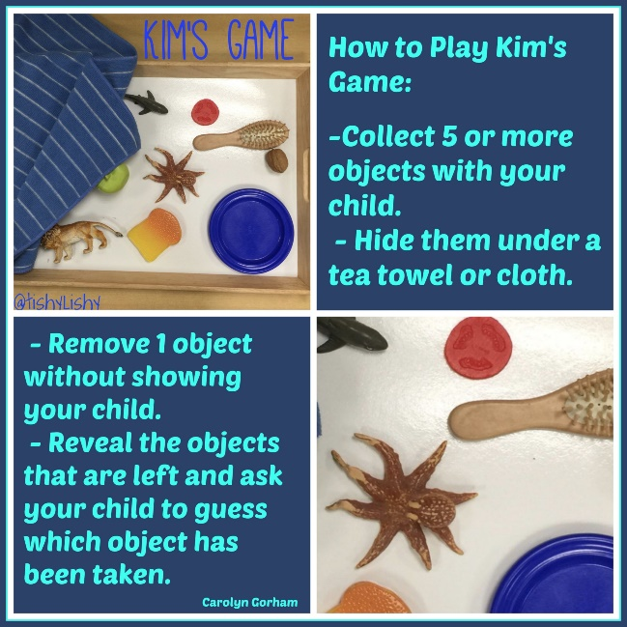
Weekly challenge ideas:
Remember! You don’t have to complete a challenge each day. You may want to choose one and spread it out over a few days. Come back to it at different times and keep seeing what new ideas you have! One activity can be enhanced in so many ways!
Ways to
Giraffe Class LOVE story telling. Have a go at encouraging them to make up their own using a random set of objects. I promise you, the more they practise, they’ll start to surprise you with their amazing ideas!

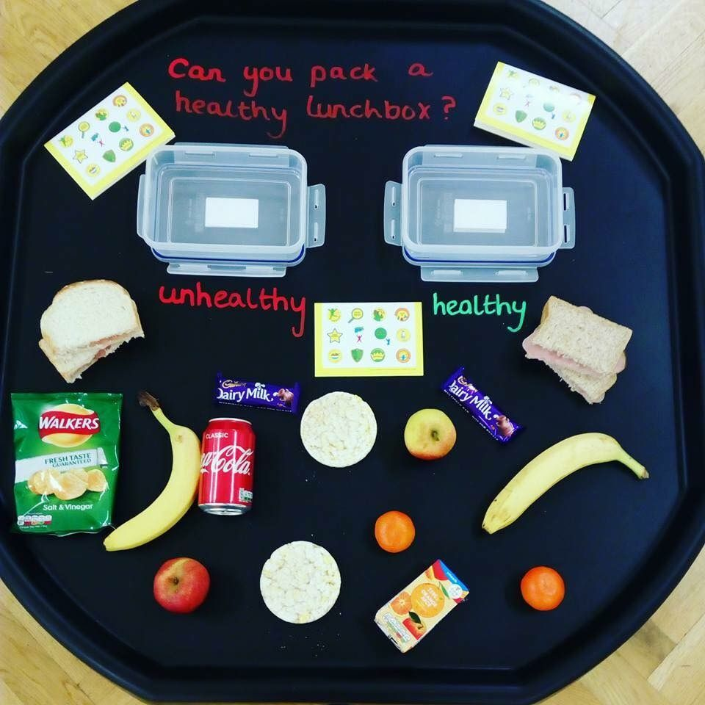
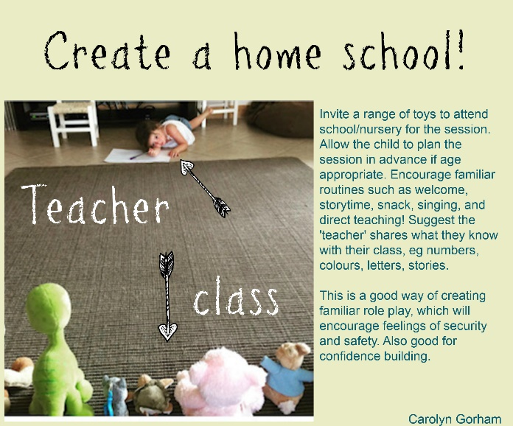
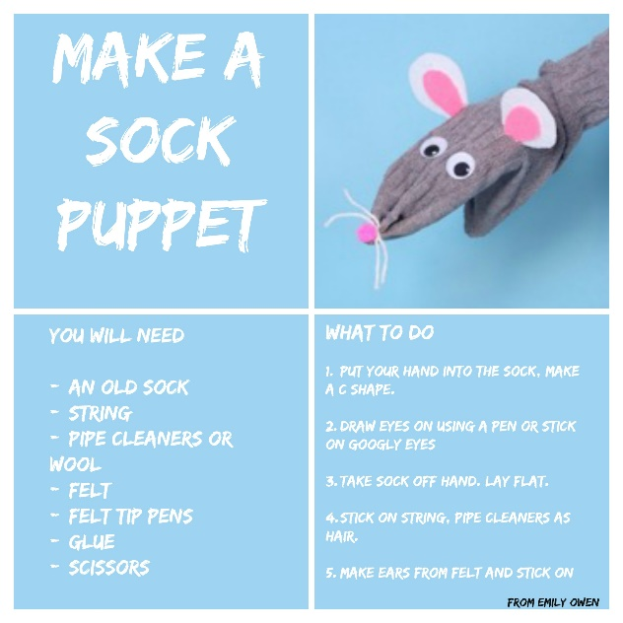

Healthy eating! Provide your child with a range of food. Ask them to pack a healthy packed lunch and see what they choose. Discuss the importance of vitamins, minerals, fibre and fats in your diet to help support strong bones, teeth and growth.

Have a go at encouraging your child to make a plan first of all. They can label their plan and then get crafty! How about making a story up all about your new character?

There are so many ways to extend a child’s learning through role play as a teacher. Have a go at:
- Writing your own register.
- Counting how many children are in.
- Teaching your pupils a new skill.
- Talking about ways to keep happy and healthy.

Reading books! - Follow this link to find many more decodable e books for your children to read. Find one that suits their level. If you want support with this, then please email me.
Thank you for everything!
Maisie
https://www.readinga-z.com/phonics/decodable-books/

