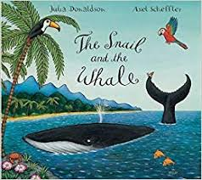
08.07.19 What did you think of the book The Snail and the Whale by Julia Donaldson?
I liked… | I didn’t like…
Things that puzzled me… | It reminded me of…
Complete the ‘Tell Me’ grid to share your ideas.

