Homophones are words which sound the same but are spelt differently and have different meanings.
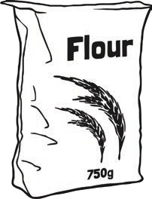
Match the pictures to the words.

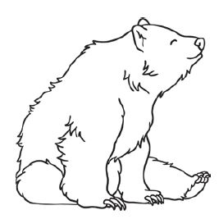  1 | 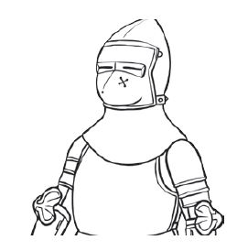  2 | 3 | 4  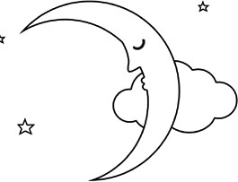
5  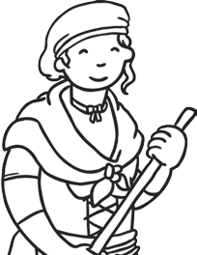 | 6  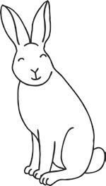 | 7  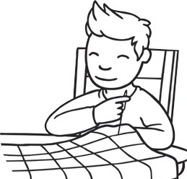 | 8  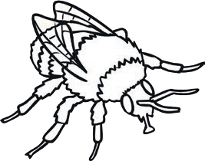
9  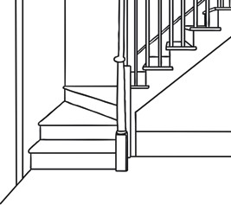 | 10  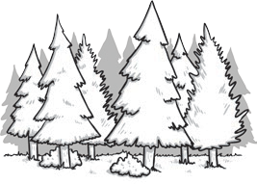 | 11  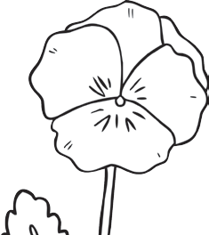 | 12  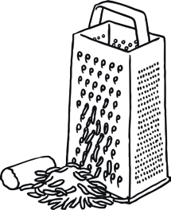

 | bare |  | bear |  | maid |  | would
 | wood |  | grate |  | knight |  | hare
 | flower |  | stair |  | night |  | bee
 | sew |  | be |  | so |  | flour
 | great |  | hair |  | made |  | stare

Complete the sentences by neatly crossing out the incorrect homophone.

- Last knight/night I went for a walk in the moonlight.

- Blue/blew is my favourite colour.

- If you want to go on holiday, you’ll have to catch a plane/plain.

- I brush my hare/hair every day.

- The lion had huge paws/pours.

- Thomas couldn’t wait to meat/meet the new teacher.

- Bernard got mud on his new/knew shoes.

- I’m over here/hear!

- Benny’s hiding over they’re/there/their.

- Suzanne scraped her knee and now it’s really saw/sore.

These words are all homophones. Try to define what each one means.

or: oar:

sale: sail:

here: hear:

tail: tale:

pail: pale:

pour: poor:

male: mail:

Find homophones for these words: week

place

read

rode

board

sea

there

boy

right

witch

peel

four

serial

son

know

waste

heel

tail

pane

weight

poor

mail

Some of these words are homophones. Circle them.

pair | mane | waste | sweat
late | hear | rice | reed
mummy | care | seen | father
plaice | oar | check | plug
hour | paint | rain

Copy this passage out, correcting the homophones as you do:
It was knight and the sky was pooring with reign. The hole ship rocked on the stormy see and the wind blue hard tearing the sale. The captain new they kneaded to fix it quick, so he called out to too crewmen. As the pear ran off to fetch knew rope the captain, who usually had nerves of steal, preyed that the ship wood knot sink. Suddenly, a peace of would broke off from the deck and flue towards him!

Page 1

 | bare | 1 | bear | 5 | maid |  | would
10 | wood | 12 | grate | 2 | knight | 6 | hare
11 | flower | 9 | stair | 4 | night | 8 | bee
 | sew |  | be |  | so | 3 | flour
 | great |  | hair |  | made |  | stare

Page 2
- Last night I went for a walk in the moonlight.
- Blue is my favourite colour.
- If you want to go on holiday, you’ll have to catch a plane.
- I brush my hair every day.
- The lion had huge paws.
- Thomas couldn’t wait to meet the new teacher.
- Bernard got mud on his new shoes.
- I’m over here!
- Benny’s hiding over there.
- Suzanne scraped her knee and now it’s really sore. Page 3
Child’s own answers.
Page 4
Child’s own answers.
Page 5
It was night and the sky was pouring with rain. The whole ship rocked on the stormy sea and the wind blew hard, tearing the sail. The captain knew they needed to fix it quick so he called out to two crewmen. As the pair ran off to fetch new rope, the captain, who usually had nerves of steel, prayed that the ship would not sink. Suddenly a piece of wood broke off from the deck and flew towards him!

